
Year 6 Maths -Spring 1- Algebra
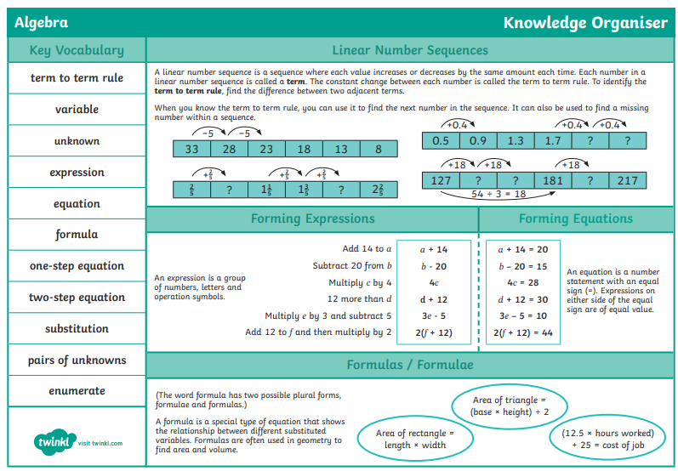

Knowledge Organiser
Year 6 Maths -Spring 1- Algebra
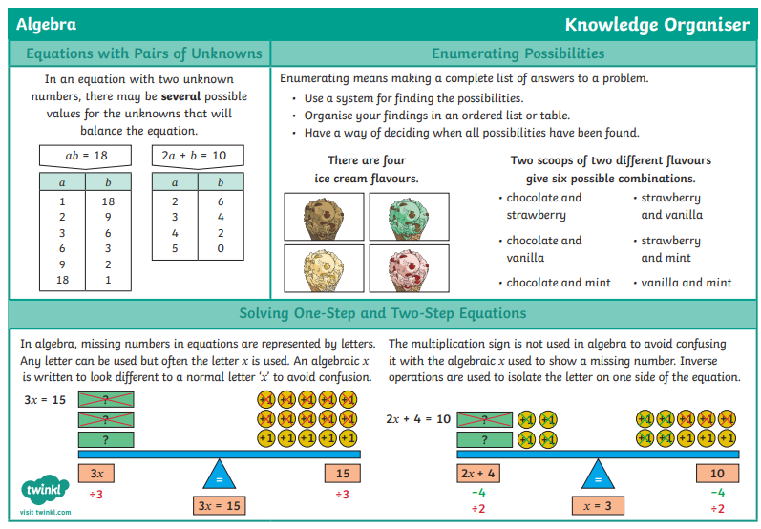

Knowledge Organiser

