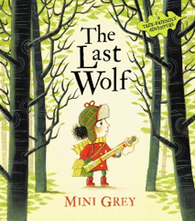
Vocabulary:
flung supplies lurk
pounce wander endless
grazing awash pickings nowadays popgun stalking
bracken tree stump land doorknob lynx human
miles earth

Handwriting: We will continue to focus on consistently using the non-cursive handwriting style.

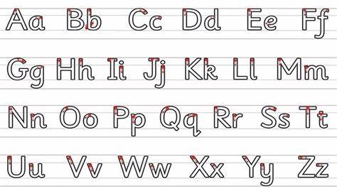
Writing Outcome: To write a letter in role persuading the characters to save the trees.
Focus:
Include detail and description
Use a range of sentence forms
Write in 1st person
Include personal comments and own viewpoint
Use openings and closings e.g. dear

Grammar and Punctuation:

- Use subordination (if, that)

- Add -er and -est to adjectives

- Use homophones and near homophones

- Use punctuation correctly – apostrophes for contracted forms

