

Homework Guidance Policy

April 25

Principal: Mrs L Smith
Chair of Governors: Mrs K Cliffe

Review Date: April 28

Cranberry Academy Homework Guidance

What are the aims of this guidance?

- To ensure a consistent approach to homework throughout the school.
- To ensure that teachers, parents and children have a clear understanding regarding expectations for homework.
- To ensure that teachers, parents and children are fully aware of the role they play with regard to homework.

What is the purpose of homework?

- To consolidate, reinforce and extend skills and understanding particularly in English and Maths.
- To provide opportunities for parents and children to work together.
- To allow parents to gain an understanding of what children are learning in school.
- To allow children to progress towards becoming more independent learners.

What is the role of the Academy?

- To provide parents with a clear policy regarding homework.
- To ensure this policy is fully and consistently followed.
- To provide support for parents with information about homework.

What is the role of the teacher?

- To plan and set a programme of homework that is appropriate to the needs of the child.
- To ensure all children understand the homework they have been given.
- To mark and give feedback about homework.
- To be available to talk to parents and children about homework.
- To inform parents if there is a problem regarding homework.

What is the role of the parent?

- To support the child in completing homework.
- To ensure the child completes homework to a high standard and hands it in on time.
- To provide the appropriate conditions for the child to complete the homework.

- To provide the appropriate resources for the child to complete the homework.

What is the role of the child?
- To ensure they have everything they need to complete homework each week.
- To make sure they understand the tasks that have been set.
- To put in the same level of effort as would be expected of class work.
- To hand the homework in on time.
- To take on board any feedback about homework.

Knowledge Organisers
At the start of each term, class teachers will send home knowledge organiser for key areas of learning for the term. These will shared on the school website.

Homework in the Foundation Stage

Learning together is the emphasis for children in the Foundation Stage. It is an ideal time to lay the foundations for continuing work at home.

What type of work will my child get? Reading
Parents will be informed of the themes, phonemes and high frequency words that the children are learning in school each half term.
Starting in the Autumn term and continuing all year, the main emphasis is on reading at home. This should be done in two ways.
- Adults reading to children.
Parents are encouraged to read regularly to their children. Parents should encourage children to point to words as they are being read. Discussion about the books is also important.

Children reading to an adult.
When they are ready to, children will start bringing simple books home to read to an adult. Again, encouraging the child to point to the words as they are being read is important. Discussing the story and the characters and asking questions about the book will help with the child’s understanding of language.

Homework in FS1
Home learning books are sent home regularly for parents to work on with their children. Activities and tasks are suggested that reinforce learning and topics explored in school. Reading books will also be sent home for parents to share with their children. We also encourage parents to share any activities or achievements that the children complete at

home for us to celebrate in school. This can include photographs or drawings the children are proud of.

Homework in FS2

Children are expected to read at least X3 a week, with parents commenting and signing the ‘Go Read’ app. Alongside this, children will receive a homework grid with activities on covering the different areas of learning. They get to choose 1 activity a week to complete, over the half term. (see below)
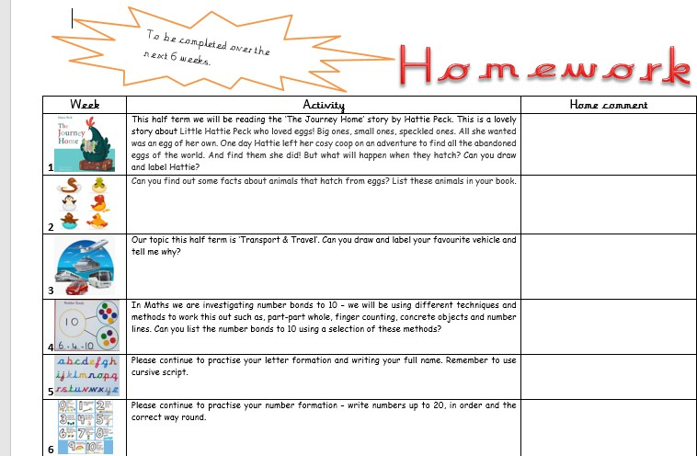

Homework in Key Stage1.
For children in Key Stage One, we encourage parents to work together with their child to support them with their homework.

What type of work will my child get? Reading
Reading on a regular basis is vital when children are in year one and two. Children will bring their reading books home every evening and the role of the adult is to listen and support them at least 3 x a week. It is important to remind them to use different

strategies to read new words, sounding out the word, looking at the pictures and looking for words within words are ways in which the child can read an unknown word. Just as important is discussing the book to check that the child has understood what they have read. Children / parents will record their reading on the Go Read App.

Phonics and Spellings
Children will have phonics or spelling sessions throughout Key Stage 1, which will also include ways that children can build up a secure sight vocabulary. It is vital that children build up a bank of words which they can read and spell on sight.
Children will bring home a weekly phonic/spelling activity related to the phonics or spelling pattern they have learnt during the week.

Maths task
A piece of Maths homework will be sent on a weekly basis. Work will be set which reinforces the learning taking place in the classroom that week and the development of basic skills.

How much time should be spent on homework?

10-15 minutes reading daily 5 mins spelling
1 X 15 minutes Numeracy

Year 1 and 2

Homework in Key Stage 2.

As children get older, homework provides an opportunity for them to develop the skill of independent learning. It is important that parents support their children, but good habits of independent study should be encouraged.
The main focus for homework in Key Stage 2 continues to be English and Maths however, children may be given more varied tasks in other areas of the curriculum.

What type of work will my child get? Reading
Children may read to an adult, with an adult or read to themselves in the presence of an adult. The story and characters should be talked about and new words discussed. Older children need a clear understanding of the story that sometimes will go beyond the literal meaning of the text. Children will read texts that are more detailed and will take longer to read. They should be encouraged to read all types of texts including non- fiction. Reading in KS2 will be recorded by parents or children on the Go Read App at

least 3 x a week.

Maths
This will also be based around what the children will be learning in class. The work could be linked to lessons on shape, measures or handling data. Lots of the activities will be based around number work. Children will be asked to make sure they know their tables from 2 to 10. They should be able to recite them and answer mixed questions.

Other Areas.
Work could be linked to any other curriculum area, Science, Geography, History and so on. It could take many forms, preparing a talk, completing a piece of research or conducting an interview.
The nature of this work may be more open ended than in other areas.
In year 6, additional revision and consolidation activities may be set to support with SATs preparation.

How much time should be spent on homework?

Year 3 and 4 | 15 minutes reading, at least 3 x per week.  1 x 15 minute tasks in Maths, English or another curriculum area.
Year 5 and 6 | 20 minutes reading at least 3 x per week  2 x 20 minutes tasks in English and Maths

How can parents find out more information about homework?

Each year group will inform the parents about homework in the welcome to the year letter or class webpage.
Teachers will have different systems for handing in homework and they will tell parents and children about this at the beginning of the year.
If parents need advice on how to support their children with homework, then they can talk to the class teacher.

Why will children sometimes be given extra homework?

Occasionally, children who work in small groups or one to one situation with teaching assistants will sometimes be given extra homework. In these cases, children should complete this work alongside their normal homework unless the child or the parents have been told otherwise. If the child is finding they have too much work, then parents should speak to the child’s teacher or teaching assistant who is providing the support.

What about children who don’t complete homework?
The expectation is that children will complete homework. Teachers will keep records of children completing homework and these records will be checked on a regular basis. If there are any problems with children not completing homework, then the teacher will speak to parents to find out why. There may be occasions when a child will miss part of playtime or lunch time if they have not completed homework to complete the missed task.

What if a child says they have received no homework?

There may be occasions if the teacher is away that the homework is not set but we will try to avoid that happening. If in doubt, please contact the school or your child’s class teacher.

How will the homework be marked?
Teachers will mark children’s homework in a variety of ways but always according to the school’s marking policy. Generally, the work will be initialled or stamped by the teacher to show they have checked it. Teachers generally will not mark homework that is handed in late.

