
Year 6 Maths -Spring 2- Properties of Shapes
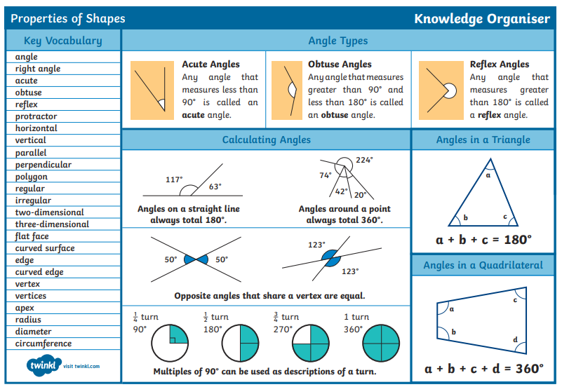

Knowledge Organiser

Year 6 Maths -Spring 2- Properties of Shapes
Knowledge Organiser
