PE
Progression Map

End of EYFS
Three and Four-Year-Olds | Physical Development | By the end of Nursery, children should be taught to:  •Can tell adults when hungry or tired or when they want to rest or play.  •Observes the effects of activity on their bodies.  •Understands that equipment and tools have to be used safely.  •Gains more bowel and bladder control and can attend to toileting needs most of the time themselves.  •Can usually manage washing and drying hands.  •Dresses with help, e.g. puts arms into open-fronted coat or shirt when held up, pulls up own trousers, and pulls up zipper once it is fastened at the bottom.  •Can tell adults when hungry or tired or when they want to rest or play.  •Observes the effects of activity on their bodies.  •Understands that equipment and tools have to be used safely.  •Gains more bowel and bladder control and can attend to toileting needs most of the time themselves.  •Can usually manage washing and drying hands.  •Dresses with help, e.g. puts arms into open-fronted coat or shirt when held up, pulls up own trousers, and pulls up zipper once it is fastened at the bottom.
Reception | Physical Development | By the end of Reception, children should be taught to:  - Experiments with different ways of moving.  - Jumps off an object and lands appropriately.  - Negotiates space successfully when playing racing and chasing games with other children, adjusting speed or changing direction to avoid obstacles.  - Travels with confidence and skill around, under, over and through balancing and climbing equipment.  - Shows increasing control over an object in pushing, patting, throwing, catching or kicking it.  - Uses simple tools to effect changes to materials.  - Handles tools, objects, construction and malleable materials safely and with increasing control.  - Shows a preference for a dominant hand.  - Begins to use anticlockwise movement and retrace vertical lines.  - Begins to form recognisable letters.  - Uses a pencil and hold
Early Learning Goals | Moving and Handling  Health and Self-Care | - Children show good control and co-ordination in large and small movements. They move confidently in a range of ways, safely negotiating space. They handle equipment and tools effectively, including pencils for writing.  - Children know the importance for good health of physical exercise, and a healthy diet, and talk about ways to keep healthy and safe. They manage their own basic hygiene and personal needs successfully, including dressing and going to the toilet independently.

KS1 National Curriculum Expectations | KS2 National Curriculum Expectations
Pupils should be taught how to:  - develop fundamental movement skills,  - become increasingly competent and confident and access a broad range of opportunities to extend their agility, balance and coordination, individually and with others.  - engage in competitive (both against self and against others) and co-operative physical activities, in a range of increasingly challenging situations.  - ▪master basic movements including running, jumping, throwing and catching, as well as developing balance, agility and co-ordination, and begin to apply these in a range of activities  - participate in team games, developing simple tactics for attacking and defending  - perform dances using simple movement patterns. | Pupils should be taught how to:  - develop a broader range of skills, learning how to use them in different ways and to link them to make actions and sequences of movement.  - enjoy communicating, collaborating and competing with each other.  - develop an understanding of how to improve in different physical activities and sports and learn how to evaluate and recognise their own success.  - use running, jumping, throwing and catching in isolation and in combination  - play competitive games, modified where appropriate [for example, badminton, basketball, cricket, football, hockey, netball, rounders and tennis], and apply basic principles suitable for attacking and defending  - develop flexibility, strength, technique, control and balance [for example, through athletics and gymnastics]  - perform dances using a range of movement patterns  - take part in outdoor and adventurous activity challenges both individually and within a team  - compare their performances with previous ones and demonstrate improvement to achieve their personal best.  - swim competently, confidently and proficiently over a distance of at least 25 metres  - use a range of strokes effectively [for example, front crawl, backstroke and  - breaststroke]  - perform safe self-rescue in different water-based situations.

Intent
We aim to provide a broad and balanced P.E. curriculum to aid children’s increasing self-confidence in their ability to manage themselves and their bodies within a variety of movement situations. A balance of individual, team, co-operative and competitive activities aims to cater for individual pupil’s needs and abilities.
At the heart of the PE curriculum lies inclusive practices, which enable children of all backgrounds and abilities to effectively participate in PE. Our curriculum is based on progressive learning objectives that, combined with varied and flexible teaching styles, endeavour to provide appropriate, stimulating, challenging and enjoyable learning situation for all pupils. The curriculum aims to promote an understanding of the many benefits of exercise, through a balanced range of relevant activities.
In addition to the importance placed on PE lessons, we also have a wider curriculum offer, which includes the opportunities for pupils to take part in extra-curricular sports and activity clubs and competitions. Daily physical activity and health enhancing activities also play a crucial role in our offer to pupils including active lessons, active break and lunchtimes and extra-curricular activities.

Implementation
At Cranberry Primary Academy, we are committed to providing outstanding PE provision. We employ a specialist Sports Coach, Mr Tinsley, who teaches PE to all classes throughout the school, in addition to weekly PE sessions taught by Class Teachers. Children also benefit from fortnightly specialist Outdoor Education lessons.
Pupils within EYFS undertake daily physical exercise within their teaching unit, through continuous provision, including the recent development of our outdoor area and woodland forest schools area. Cross-curricular links enable PE activities to take place during literacy and maths.
In KS1, the curriculum focuses on fundamental key skills to develop early stages of tactical awareness and physical fitness elements of agility, balance and coordination through the introduction. Curriculum content includes ball skills and team games, gymnastic and dance activities. Children are introduced to early stages of games, gymnastics, dance, outdoor and adventurous activities and athletics.
At KS2, pupils continue to apply and develop a range of skills to enable them to become successful games players, dancers, gymnasts and athletes. Lower Key Stage 2 develop the skills required for a range of games; while upper Key Stage 2 takes this further to allow access to varied games. We also enrich children’s experiences through opportunities for outdoor and adventurous activities.
Wider Curriculum Offer
Children at Cranberry are given the opportunity to join a range of extra-curricular activities both during lunchtimes and after school. They range from traditional sports such as football and netball, and other sports such as dodgeball and hockey, to non-competitive physical activity clubs including yoga.
During lunchtimes, children in KS2 are given the opportunity to play the ‘Sport of the Week’, aiming to give children opportunities to experience a wide range of different sports whilst also developing leadership skills of the children running the sessions. Sportsmanship and team working skills are celebrated through weekly Sportsmanship Awards for each key stage, given to children who demonstrate excellent sportsmanship during Sport of the Week.
Furthermore, Children are given the opportunity to compete at various levels including personal best challenges in school and other intraschool challenges between houses, year groups and classes. We take part in many School Games events and currently hold the Platinum level School Games Mark for our participation in competitive sport.
Sports Council
At Cranberry, we have an active Sports Council and in Year 6; four children are elected to become Bronze Ambassadors. These children help to organise and run an extensive programme of inter house activities and competitions throughout the year. KS2 Sports Councillors are also given the opportunities to develop their leadership skills in Sports and Games, helping to run Sport of the Week, in addition to acting as representatives for their year groups during Sports Council Meetings. Furthermore, Playground leaders organise and lead playtime games for Key Stage 1.

Impact
As a result of a strong Physical Education curriculum and wider curriculum offer, Cranberry Primary Academy pupils will:
• Become skilful and intelligent performers
• Acquire and develop skills, performing with increasing physical awareness
• Learn how to select and apply skills, tactics and compositional ideas to suit activities that need different approaches and ways of thinking
• Develop their ideas in different ways
• Set targets for themselves and compete against others
• Understand what it takes to persevere, succeed and acknowledge others’ success
• Respond to a variety of challenges
• Take the initiative, lead activity and focus on improving performances
• Develop competence to excel in a broad range of physical activities
• Lead healthy, active lives
• Develop positive attitudes to participation in physical activity
• Engage in competitive sports and activities
• Embed values like fairness and respect
Pupil’s skills and knowledge in these areas will not only provide an excellent foundation for the next stage in their lives, but also increase their cultural capital potential in their future adulthoods.

Progression
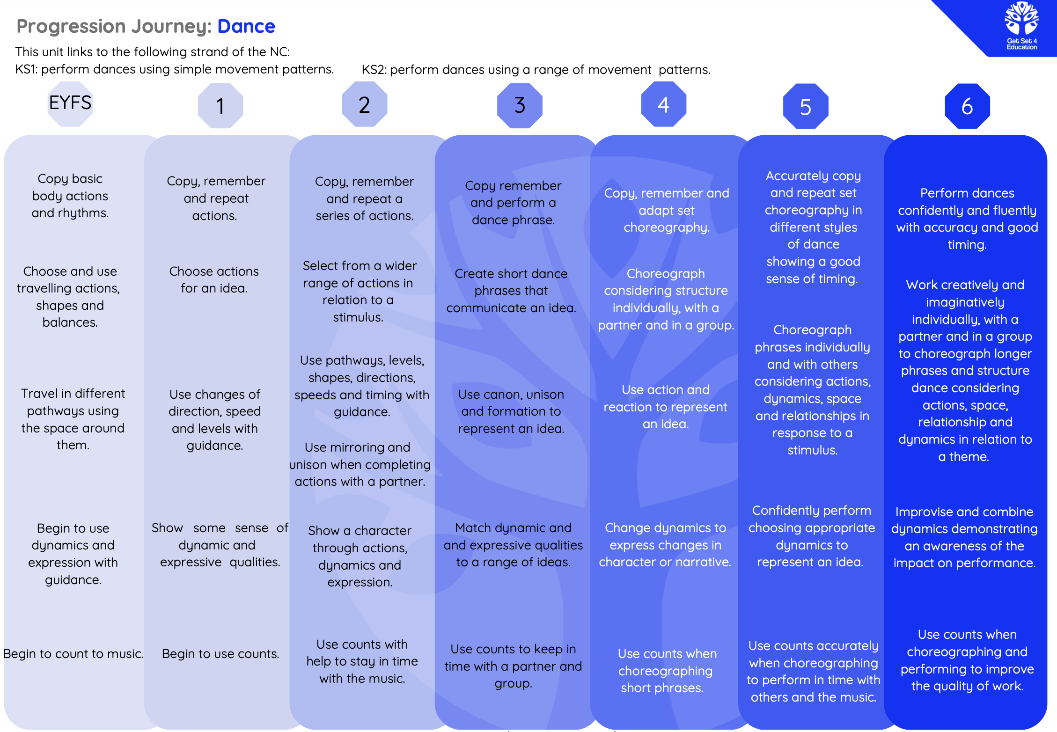

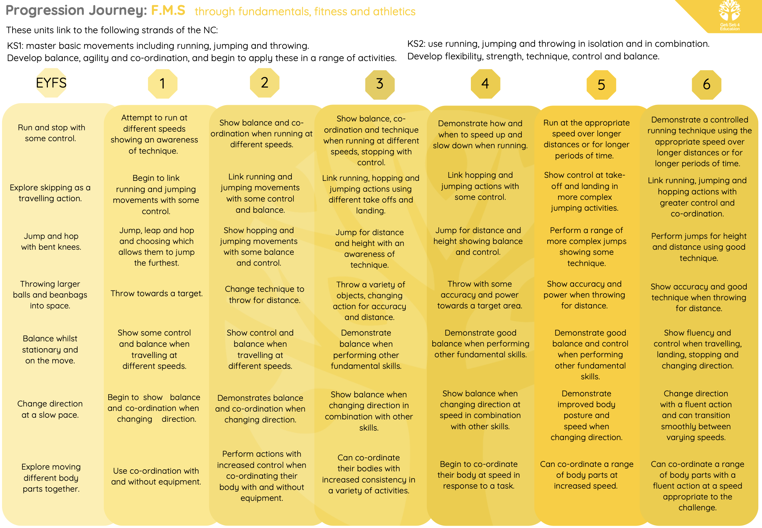
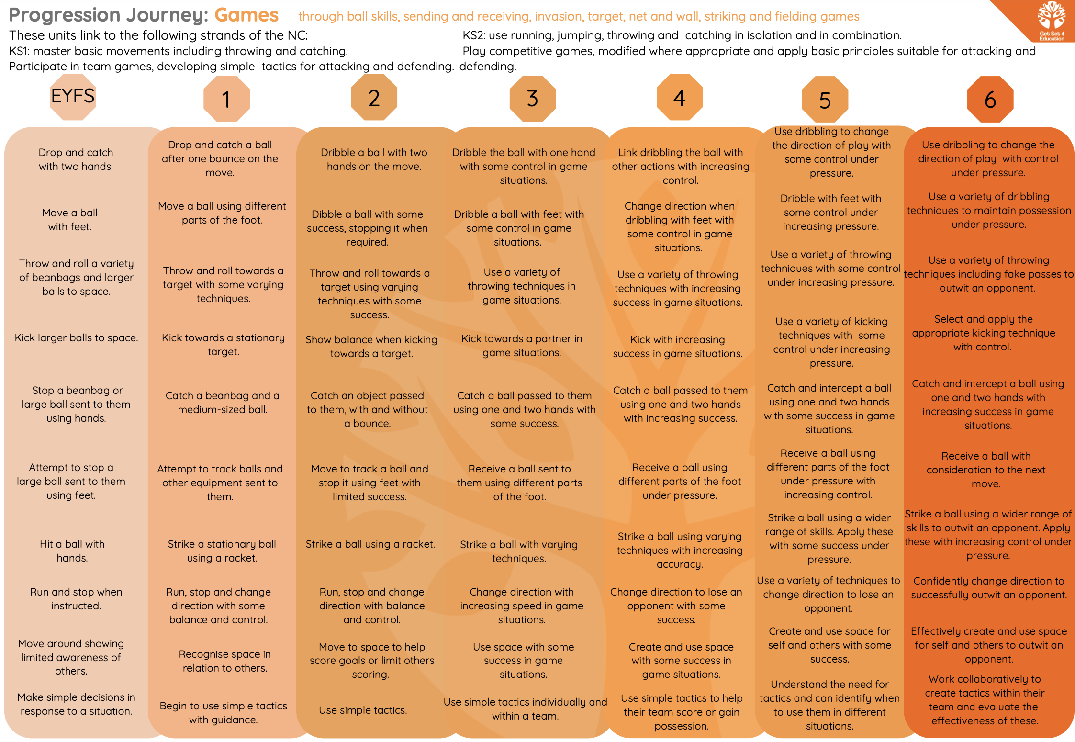
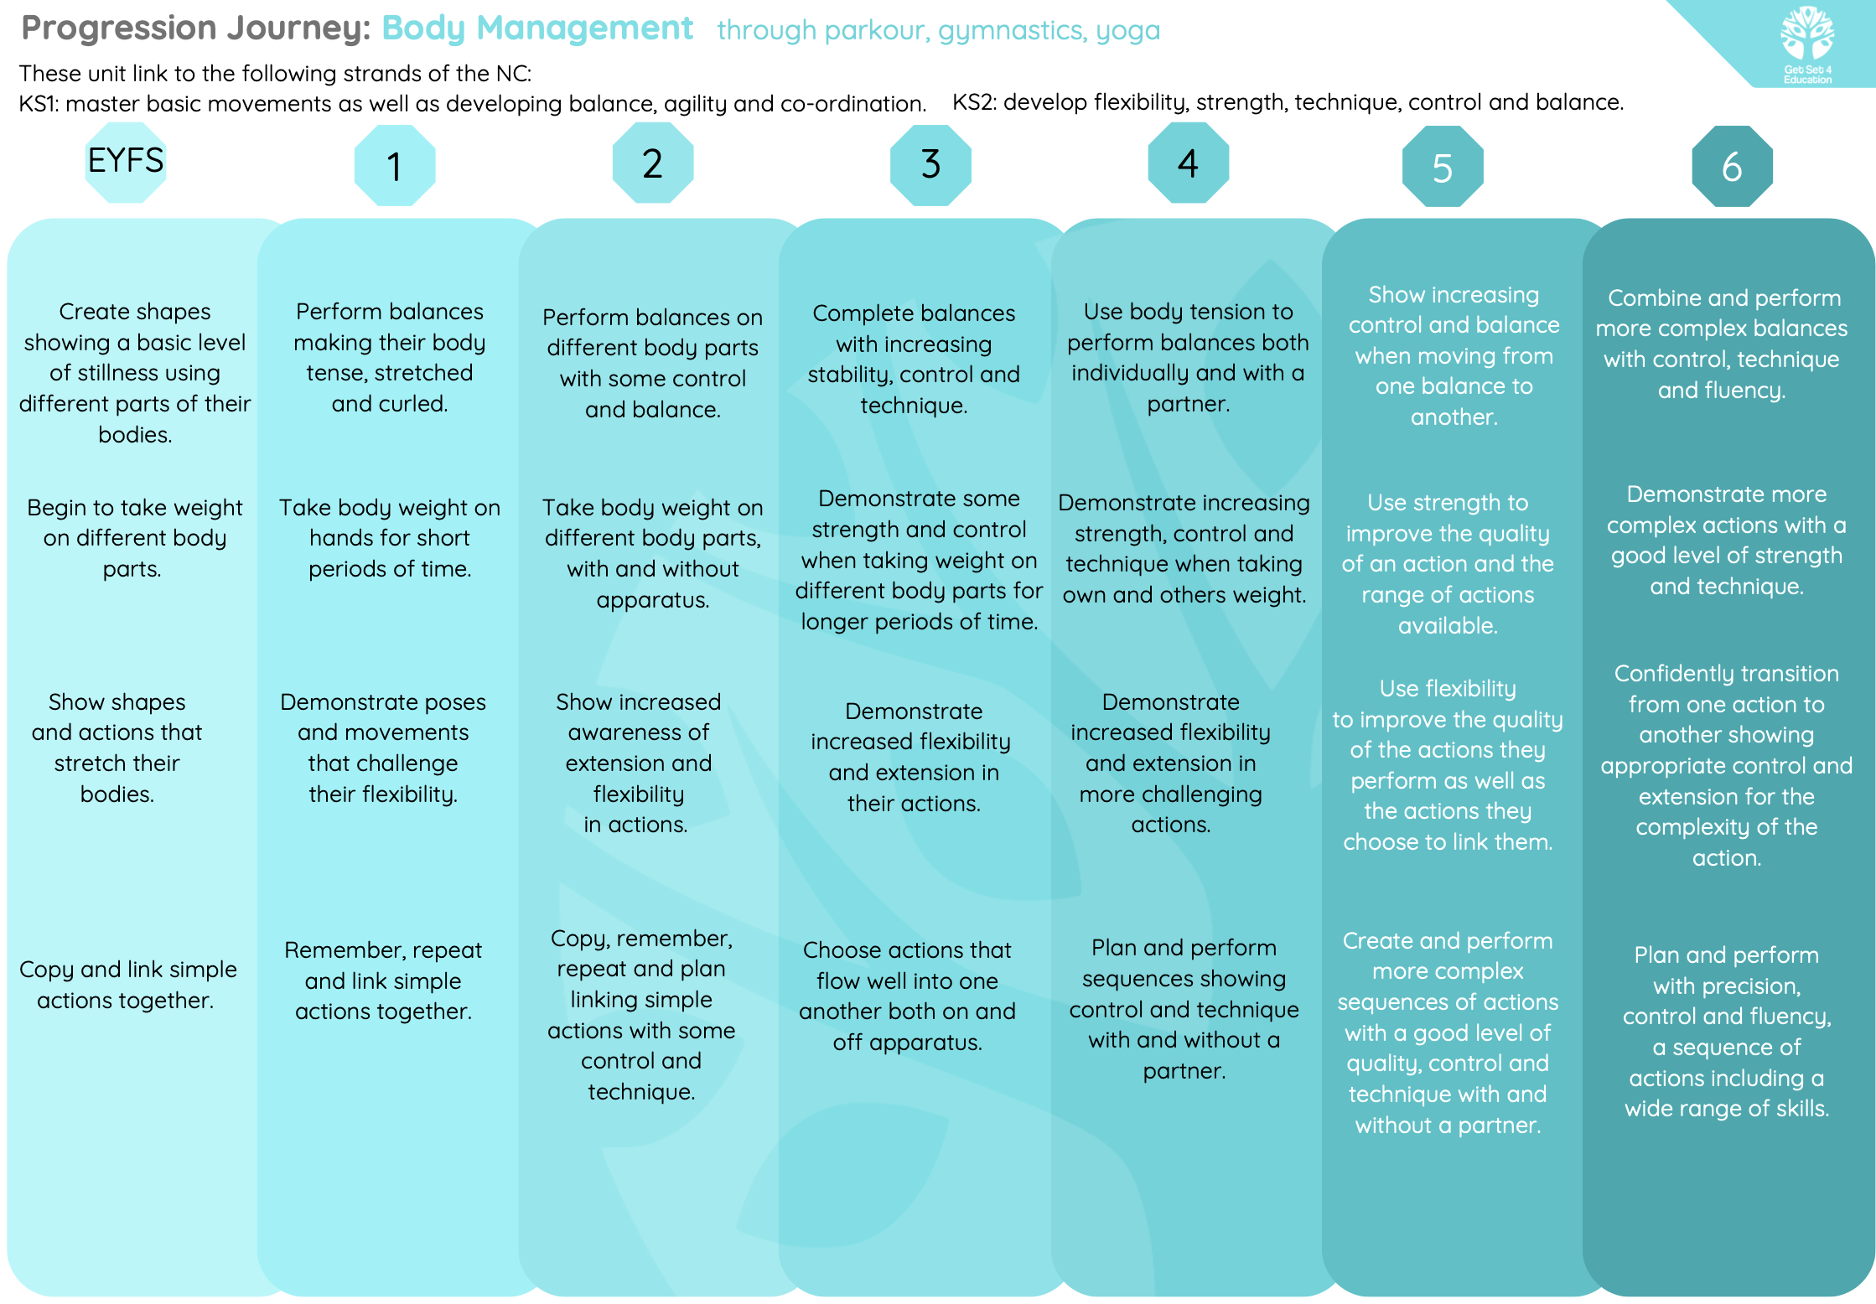
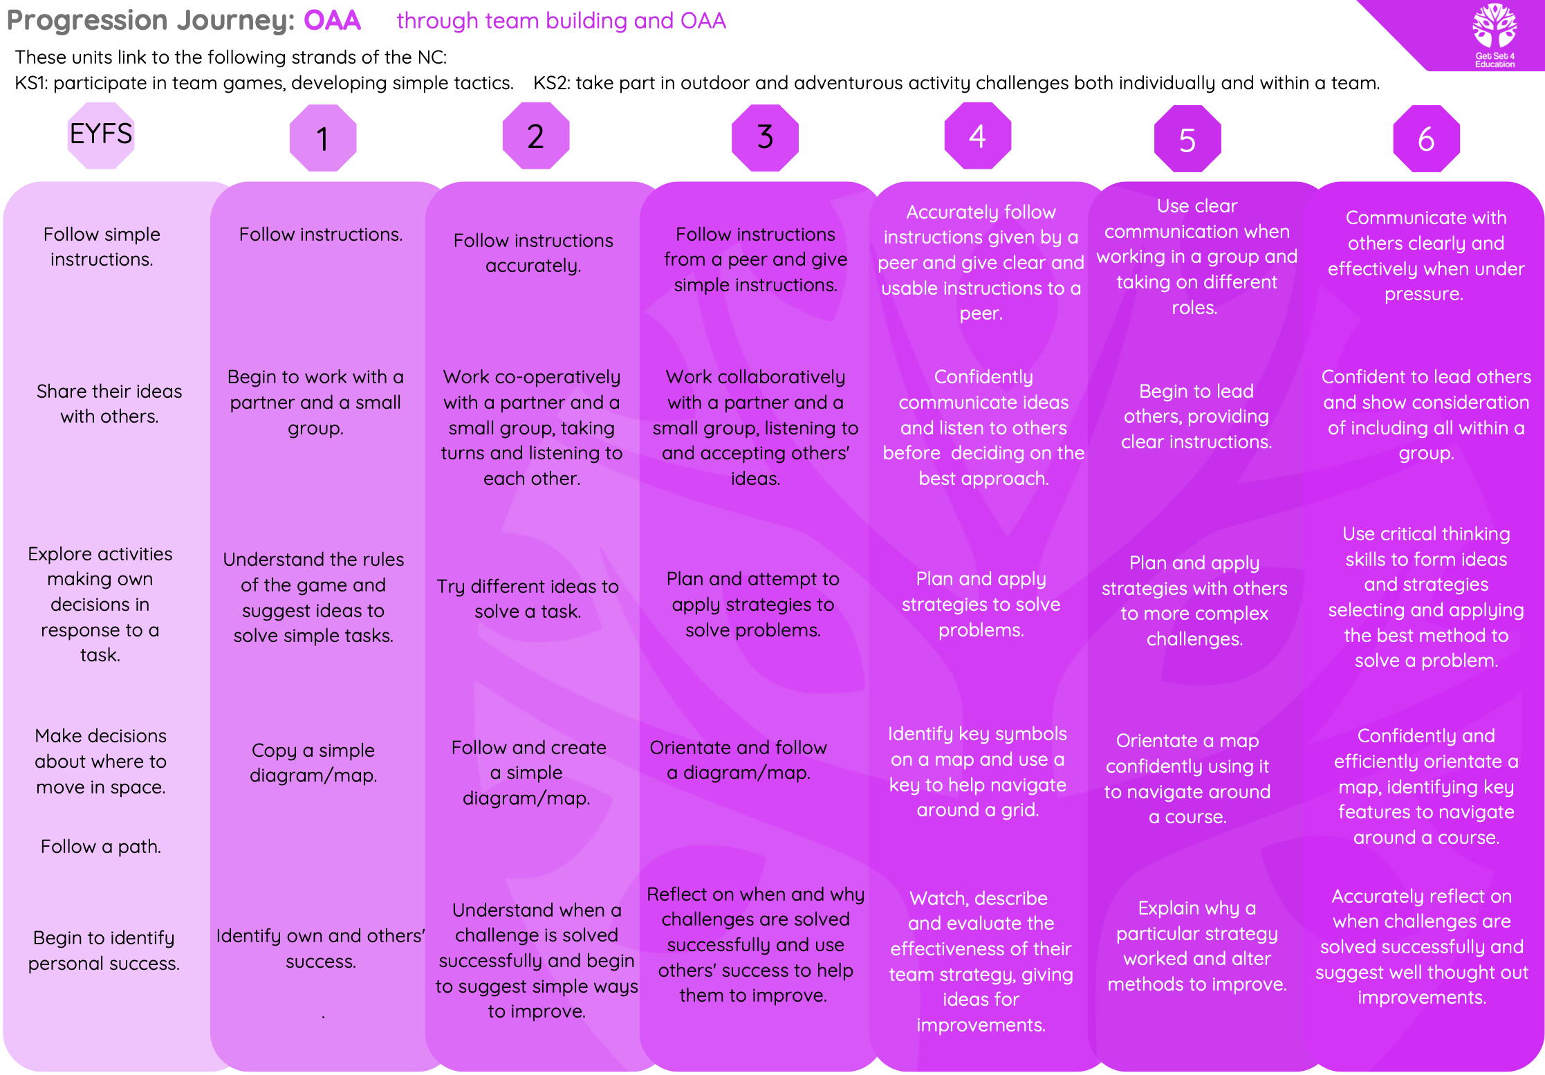
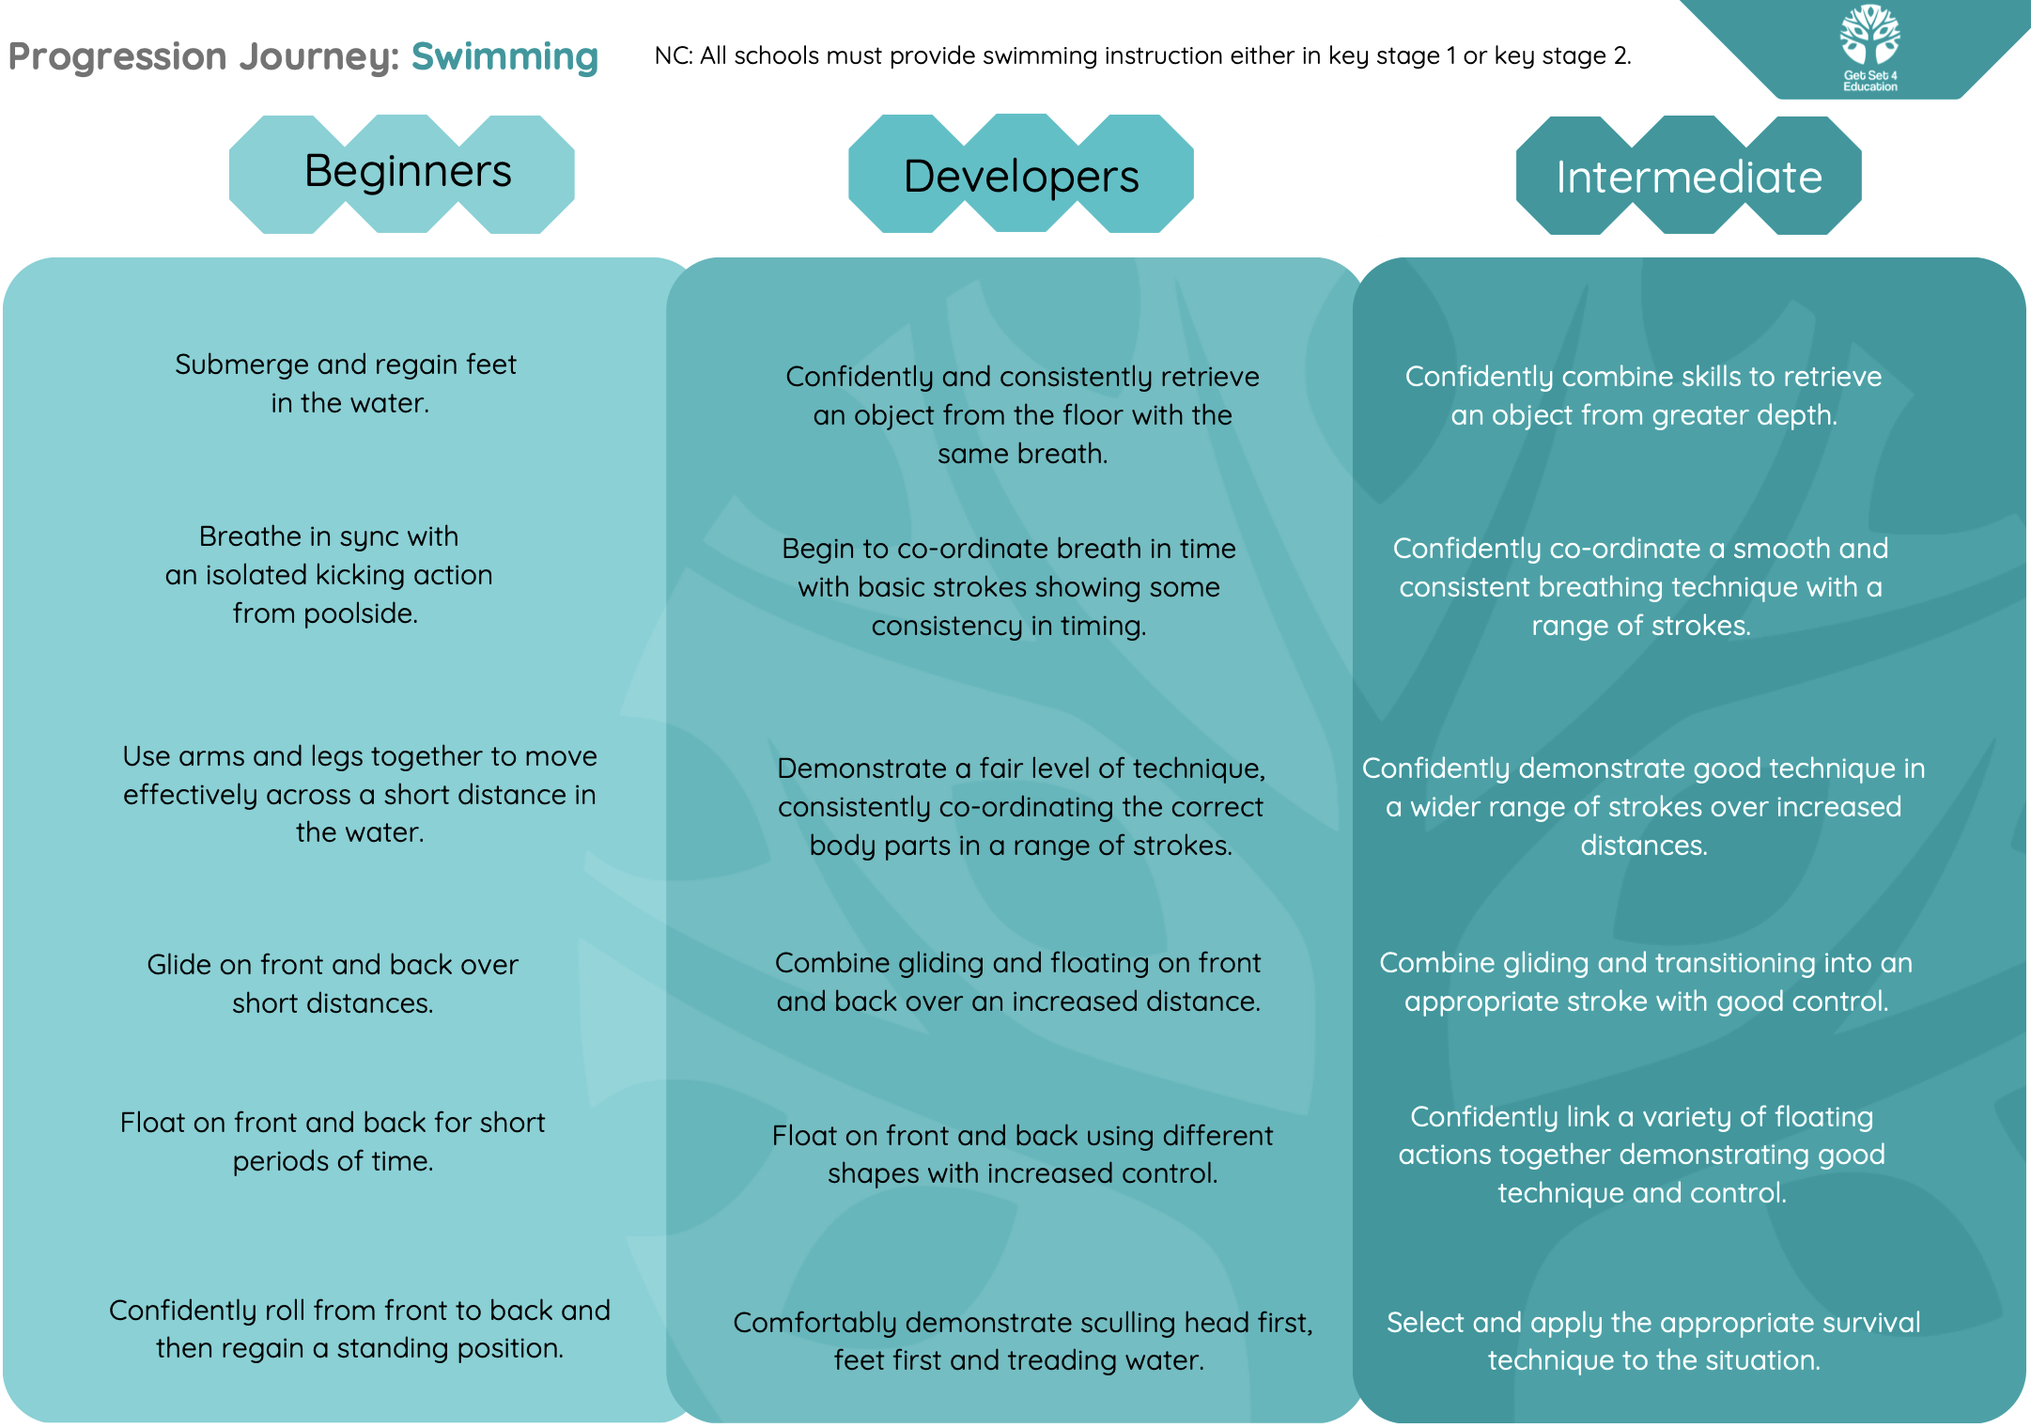
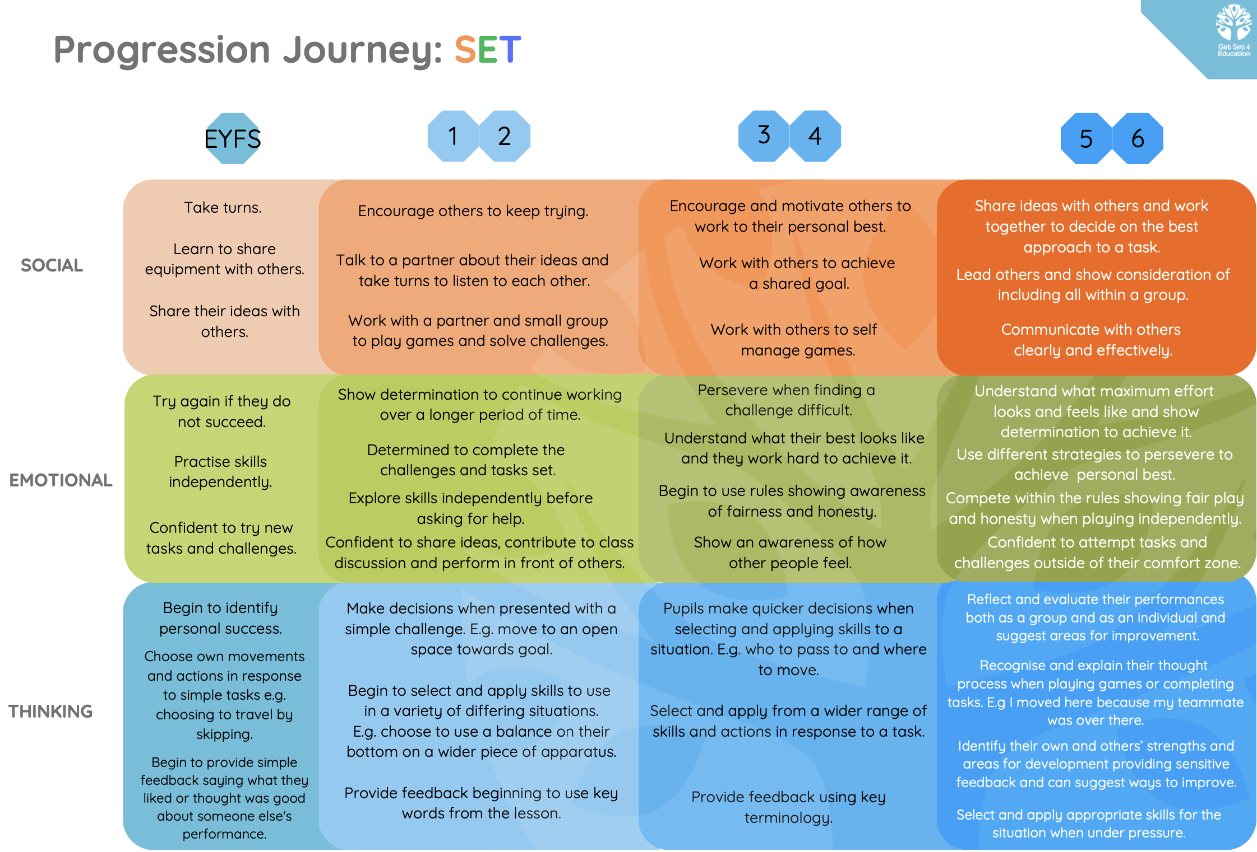
PE: Vocabulary Map
EYFS | KS1 | KS2
General Vocabulary:  - Run  - Jump  - Throw  - Catch  - Team  - Instructions  - Goal  - Points  - Follow | General Vocabulary:  - Skills  - Tactic  - Goal  - Points  - Encouragement  - Attack  - Stretch  - Muscles  - Fitness  - Defence  - Action  - Apparatus  - Striking  - Grasping  - Fielder  - Bowler  - Bowling  - Control  - Team  - Instructions  - Follow  - Challenge  - Travelling  - Pumping  - Techniques  - Sprinting  - Accuracy  - Overarm  - Distance  - Power  - Strength  - Sequence  - Arch  - Tuck  - Crab  - Movement  *Please note that each unit covered will have topic specific vocabulary. | General Vocabulary:  - Fluency  - Dynamics  - Energy  - Flow  - Explosive  - Jerky  - Coaching  - Feedback  - Endurance  - Resistance  - Stamina  - Resilience  - Glide  - Rotate  - Shallow  - Tuck  - breath  - Recurring idea (motif)  - Front Crawl  - Stroke  - Breaststroke  - Back stroke  - Butterfly  - Straddle  - Surface  - Tumble-turn  - Tread water  - Depth  - Bubbles Dive  - Length  - Width  - Metre  - Rhythm  - Sink  - Float  - Deep  - Stimuli/stimulus  *Please note that each unit covered will have topic specific vocabulary.

Long Term Plan Overview
