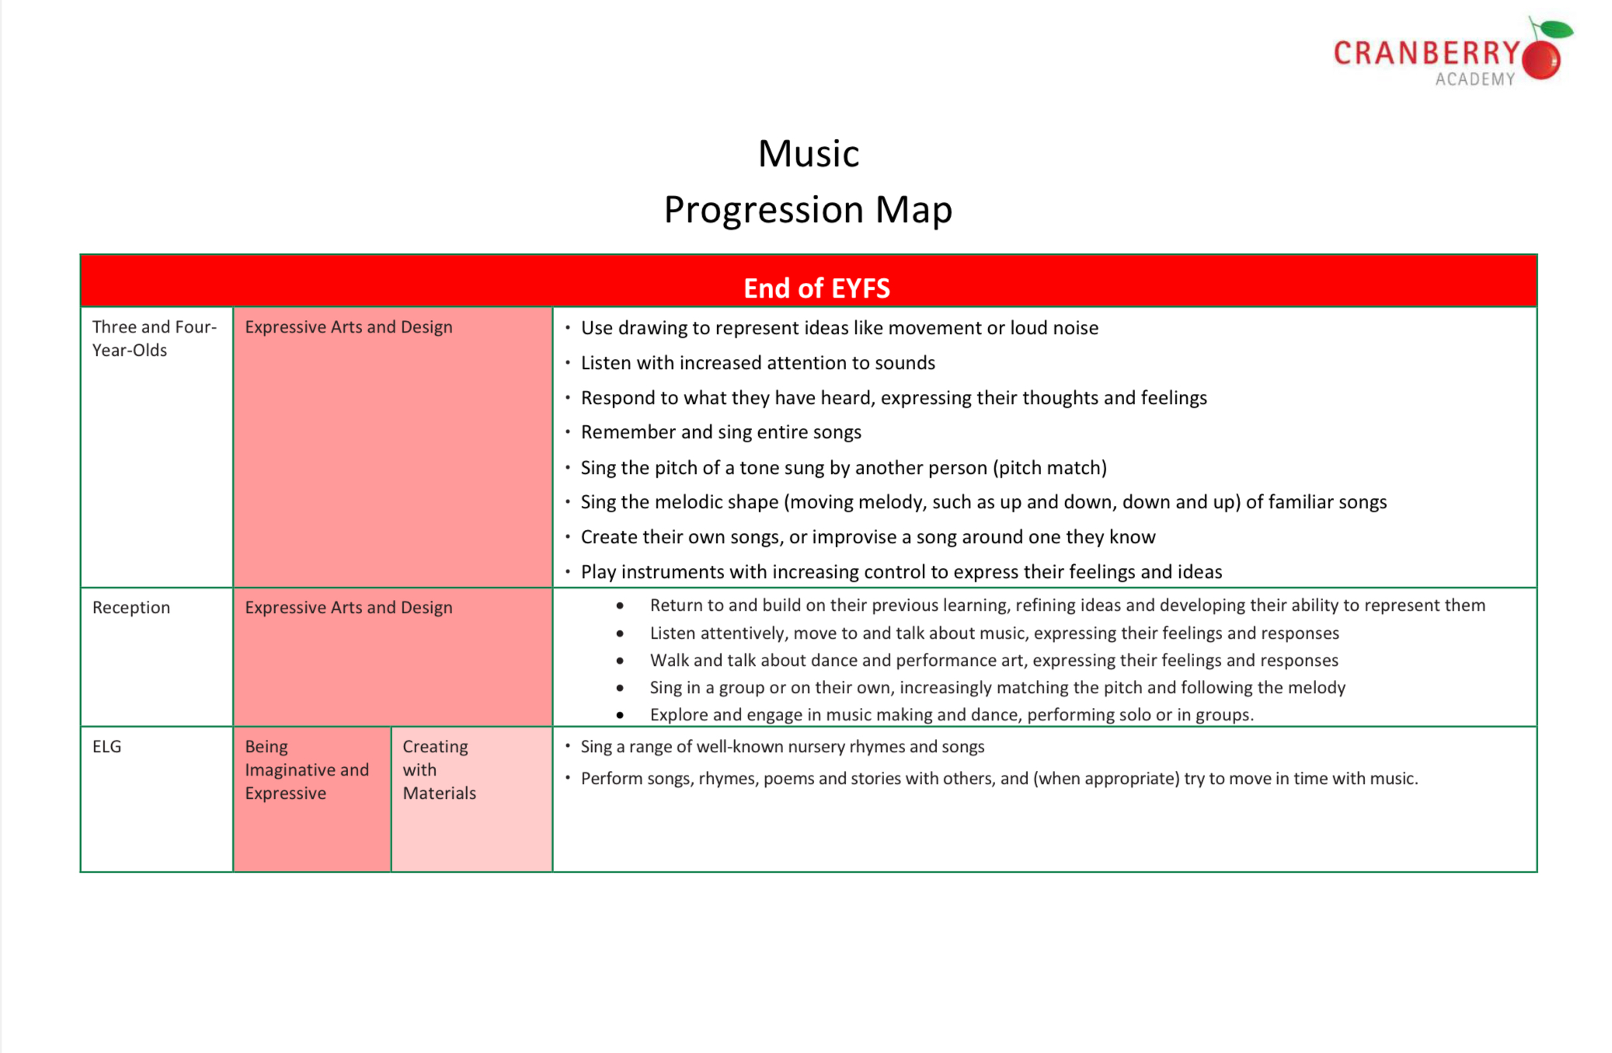
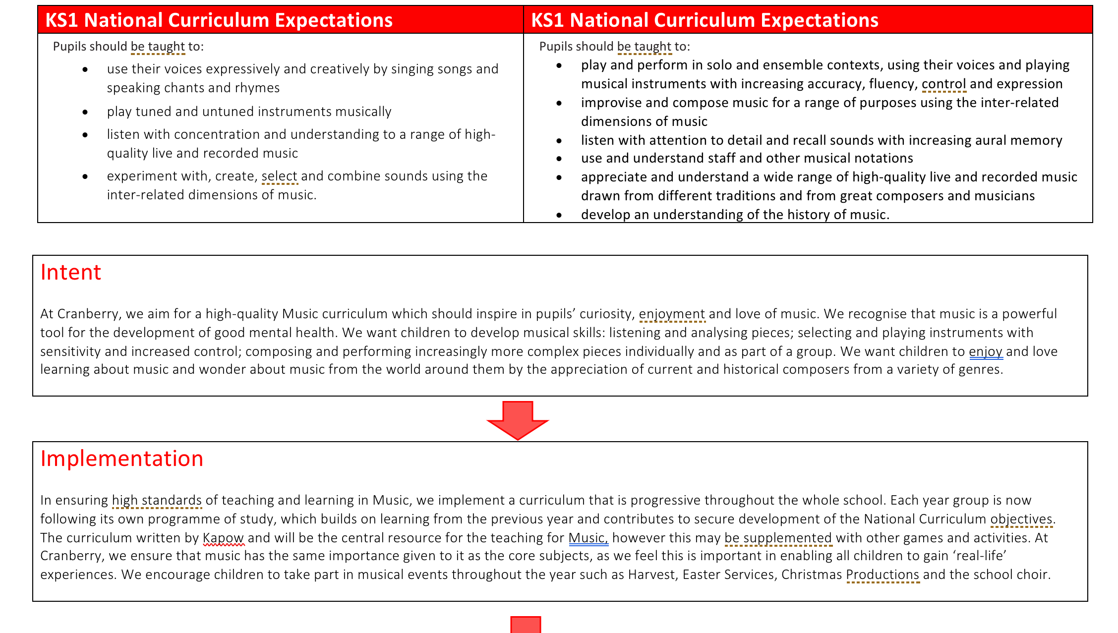
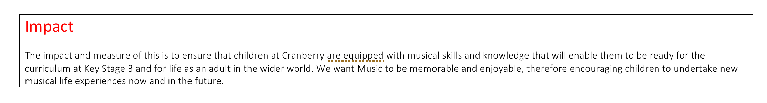

Listening and Evaluating
EYFS | Year 1 | Year 2 | Year 3 | Year 4 | Year 5 | Year 6 | National Curriculum (End KS1 & KS2)
Listening and responding to music
Listening appropriately to someone leading a short musical phrase, song or rhyme. Exploring spontaneous movement with different parts of their body in response to music. Expressing different spontaneous emotional reactions to music, (smiling, movement, body language). Using artwork or creative play as a way of expressing feelings and responses to music. Children in reception will be learning to: ● Listen attentively, move to and talk about music, expressing their feelings and responses. | Listening with concentration to short pieces of music or excerpts from longer pieces of music. Engaging with and responding to longer pieces of music. Coordinating the speed of their movements to match the speed of the music (not the beat). Beginning to move in time with the beat of the music. | Beginning to articulate how a piece of music affects them (e.g it makes them feel sleepy, it makes them want to dance, it makes them happy) Confidently moving in time with the beat of the music when modelled. Beginning to keep movements to the beat of different speeds of music. Beginning to explain why the music has a certain effect on them, which could be related to the music or a personal experience. | Explaining their preferences for a piece of music using musical vocabulary. Understanding the impact music has on them and starting to articulate the reasons for this effect using musical vocabulary. | Discussing the stylistic features of different genres, styles and traditions of music using musical vocabulary (Indian, classical, Chinese, Battle Songs, Ballads, Jazz). Understanding that music from different parts of the world has different features. Recognising and explaining the changes within a piece of music using musical vocabulary. Describing the timbre, dynamic, and textural details of a piece of music, both verbally, and through movement. Beginning to show an awareness of metre. Recognising the use and development of motifs in music. Identifying gradual dynamic and tempo changes within a piece of music. | Identifying common features between different genres, styles and traditions of music. Recognising, naming and explaining the effect of the interrelated dimensions of music. Identifying scaled dynamics (crescendo/decrescendo) within a piece of music. Using musical vocabulary to discuss the purpose of a piece of music. | Recognising and confidently discussing the stylistic features of different genres, styles and traditions of music using musical vocabulary. (South African, West African, Musical, Theatre, Blues, Dance Remix.). Representing the features of a piece of music using graphic notation, and colours, justifying their choices with reference to musical vocabulary. Discussing musical eras in context, identifying how they have influenced each other, and discussing the impact of different composers on the development of musical styles. Recognising and confidently discussing the stylistic features of music and relating it to other aspects of the Arts (Pop art, Film music). Representing changes in pitch, dynamics and texture using graphic notation, justifying their choices with reference to musical vocabulary. Identifying the way that features of a song can complement one another to create a coherent overall effect. | End of KS1: Pupils should be taught to: ● Listen with concentration and understanding to a range of high-quality live and recorded music. End of KS2: Pupils should be taught to: ● Listen with attention to detail and recall sounds with increasing aural memory. ● Appreciate and understand a wide range of high-quality live and recorded music drawn from different traditions and from great composers and musicians.
Analysing
Identifying and imitating sounds from a variety of music. Considering whether background music and sound effects can enhance storytelling. | Identifying some common instruments when listening to music. Relating sounds in music to real-world experiences. (e.g. it sounds like squelching mud). Recognising simple patterns and repetition in rhythm. (e.g. where a pattern of beats is repeated). Recognising simple patterns and repetition in pitch (e.g. do re mi). Talking about the tempo of music using the vocabulary of fast and slow. Talking about the dynamics of the music, using the vocabulary of loud, quiet and silent. Talking about the pitch of music, using the vocabulary of high and low. | Stating what they enjoyed about their peers’ performances. | Beginning to use musical vocabulary (related to the inter-related dimensions of music) when discussing improvements to their own and others’ work. | Using musical vocabulary (related to the inter-related dimensions of music) when discussing improvements to their own and others’ work. | Comparing, discussing and evaluating music using detailed musical vocabulary. Developing confidence in using detailed musical vocabulary (related to the inter-related dimensions of music) to discuss and evaluate their own and others’ work. | Use musical vocabulary correctly when describing and evaluating the features of a piece of music. Evaluating how the venue, occasion and purpose affects the way a piece of music sounds. Confidently using detailed musical vocabulary (related to the inter-related dimensions of music) to discuss and evaluate their own and others work. | End of KS1: Pupils should be taught to: ● Listen with concentration and understanding to a range of high-quality live and recorded music. End of KS2: Pupils should be taught to: ● Listen with attention to detail and recall sounds with increasing aural memory. ● Appreciate and understand a wide range of high-quality live and recorded music drawn from different traditions and from great composers and musicians.
Evaluating
Showing preferences for certain music or sounds. Children in reception will be learning to: ● Listen attentively, move to and talk about music, expressing their feelings and responses. | Stating what they enjoyed about their peers’ performances. | Giving positive feedback relating to the tempo of practices and performances using the vocabulary of fast and slow. Giving positive feedback related to the dynamics of practices and performances, using the vocabulary of loud, quiet and silent. | Beginning to use musical vocabulary (related to the inter-related dimensions of music) when discussing improvements to their own and others’ work. | Using musical vocabulary (related to the inter-related dimensions of music) when discussing improvements to their own and others’ work. | Comparing, discussing and evaluating music using detailed musical vocabulary. Developing confidence in using detailed musical vocabulary (related to the inter-related dimensions of music) to discuss and evaluate their own and others’ work. | Use musical vocabulary correctly when describing and evaluating the features of a piece of music. Evaluating how the venue, occasion and purpose affects the way a piece of music sounds. Confidently using detailed musical vocabulary (related to the inter-related dimensions of music) to discuss and evaluate their own and others work. | End of KS1: Pupils should be taught to: ● Listen with concentration and understanding to a range of high-quality live and recorded music. End of KS2: Pupils should be taught to: ● Listen with attention to detail and recall sounds with increasing aural memory. ● Appreciate and understand a wide range of high-quality live and recorded music drawn from different traditions and from great composers and musicians.
Cultural and historical awareness of music
Listening to music from a wide variety of cultures and historical periods. | Appreciating music from a wide variety of cultures and historical periods. To recognise and name at least two instruments. To know that sections of music can be described as fast or slow and the meaning of these terms. To know that sections of music can be described as loud, quiet or silent and the meaning of these terms. To know that sounds within music can be described as high or low sounds and the meaning of these terms. | Understanding that music from different times has different features. | Recognising and discussing the stylistic features of different genres, styles and traditions of music using musical vocabulary. | Confidently discussing the stylistic features of different genres, styles and traditions of music and explaining how these have developed over time. | Discussing musical eras in context, identifying how they have influenced each other, and discussing the impact of different composers on the development of musical styles. | Discussing musical eras in context, identifying how they have influenced each other, and discussing the impact of different composers on the development of musical styles. | End of KS1: Pupils should be taught to: ● Listen with concentration and understanding to a range of high-quality live and recorded music. End of KS2: Pupils should be taught to: ● Appreciate and understand a wide range of high-quality live and recorded music drawn from different traditions and from great composers and musicians.
Kapow Primary, pp. 4–7

Creating Sound
EYFS | Year 1 | Year 2 | Year 3 | Year 4 | Year 5 | Year 6 | National Curriculum (End KS1 & KS2)
Singing repertoire*
Singing short, rhythmic rhymes and songs. Children in reception will be learning to: ● Sing in a group or on their own, increasingly matching the pitch and following the melody. | Singing simple songs, chants and rhymes from memory. | Practising singing songs with a wider pitch range (e.g. pentatonic melodies) which is gradually getting higher or lower. Pupils should be taught to: ● Use their voices expressively and creatively by singing songs and speaking chants and rhymes. | To sing a widening range of songs in unison with varying styles and structures. to sing songs with a pitch range of dough to sew tunefully and with expression to perform forte and piano( loud and soft) | I can sing in tune with expression and awareness of meaning. I can continue to sing abroad range of unison songs than the range of an octave (do-do).I can pitch my voice accurately and follow our directions for getting louder (crescendo) and quieter( decrescendo) | I can sing a broad range of songs from an extended repertoire with a sense of ensemble and performance .  I can sing three part rounds partner songs and songs with a verse and a chorus . | I can perform a range of songs in school assemblies and in school performance opportunities . I can sing a broad range of songs, including those are involved syncopated rhythms as part of require the sense of ensemble and performance . I can observe rhythm phrasing accurate pitching and appropriate style when singing I can continue to sing three and four part rounds or partner songs including when no longer in discreet parts . | End of KS1: Pupils should be taught to: ● Use their voices expressively and creatively by singing songs and speaking chants and rhymes. Please note: the suggested pitch ranges and songs in the scheme are designed to gradually explore a wider pitch range over time in a focused way. During class assemblies and productions, pupils may be asked to sing or perform songs beyond these pitch ranges. Be aware that children's voices and pitch ranges develop at different rates and they may not be able to sing in tune accurately throughout the entire piece.
Singing technique
Using both speaking and singing voices. Unconsciously beginning to sing to the pulse of a song. Exploring vowel sounds through call and response activities. | Breathing at appropriate times when singing. Exploring changing their singing voice in different ways. Singing a range of call and response chants, attempting to match the pitch and tempo they hear. Adapting their singing voice to be loud or soft at the direction of a leader. | Singing a range of call and response songs, matching the pitch and tempo they hear with accuracy. Singing part of a given song in their head (using their ‘thinking voice’). | Exploring the voice. Differentiate between speaking, whispering shouting and singing voices. Sing short simple songs in tune with a limited range. Match pitch accurately through call and response begin to sing in unison. Continue to develop listening‘ for singing and understand basic breathing standing tall, silent breaths. | Developing control and confidence. Just singing in tune with increased accuracy and confidence to extend the vocal range. Begin to sing with phrasing and expression learn to sing rounds and simple partner songs and use dynamics and tempo to show musical understanding. Introduce gentle transitions between registers focus breathing exercises inhale through the nose control the exhale start to learn conductor or simple notation clues. | Refining technique and musicality. Maintain pitch and tone in small group or parts singing. Improve tone quality and addiction. Explore expressive singing including phrasing, dynamics and emotional intent. Understand and apply correct breathing for longer phrases. Work on projection without shouting . | Confident and expressive singing. Sing confidently alone in groups maintain accurate pitch and rhythm even in parts. Develop musical interpretation and stylistic awareness to prepare for performance with stage presence and focus. Demonstrate control over breath tone and diction. | End of KS1: Pupils should be taught to: ● Use their voices expressively and creatively by singing songs and speaking chants and rhymes.
Instruments
Exploring different ways of making sound with everyday objects and instruments. Exploring different ways of holding a range of instruments. Starting to show a preference for a dominant hand when playing instruments. Using instruments expressively to music. Using instruments to begin to follow a beat, with guidance. Children in reception will be learning to: ● Explore and engage in music making and dance, performing solo or in groups. | Developing an awareness of how sound is affected by the way an instrument is held. Developing an awareness of how dynamics are affected by the force with which an instrument is played. Learning to use instruments to follow the beat by first observing and then mimicking the teacher’s modelling. Using instruments imaginatively to create soundscapes which convey a sense of place. Using bilateral and hand-eye co-ordination to play/hold instruments using both hands. Starting to understand how to produce different sounds on pitched instruments. Pupils should be taught to: ● Play tuned and untuned instruments musically. | Early awareness. To be able to sit or stand comfortably with a straight back and to learn how to hold classroom instruments like tambourines triangles xylophone securely but gently to understand how posture affects sound e.g. clear versus muffled. To begin it to keep still while playing avoiding unnecessary movement and to use both hands and coordination keeping instruments that are comfortable height. | Developing control. Beginning to connect posture with playing quality. To sit or stand tall with a relaxed shoulders and balanced weight. To hold Instruments correctly and comfortably. To maintain a stable posture throughout short pieces. To begin to recognise how posture supports good tone and breath particularly for wind instruments. Learn to bring the instrument to the body not the body to the instrument . | Strength and coordination. Building endurance and alignment. To maintain a correct relaxed posture for longer periods. To be able to adjust seating or standing position for different instruments. To develop awareness of hand wrist and arm alignment to prevent tension. To understand the importance of balanced posture for control and sound quality and to be able to coordinate movements and posture more fluidly. | Independence and expression. Refining posture for comfort and musicality . to be able to demonstrate consistent posture without reminders. To adjust position naturally for different musical contacts e.g. a solo or a group. To use posture to show expressive playing and dynamic contrast. Show awareness of ensemble posture eye contact and read to play. To maintain focus and relaxation through performances or longer rehearsals. To have a good understanding of the ukulele how to hold it for the best sound quality . | Confidence and mastery. To have confident expressive and ergonomic posture. To maintain a balance to relax posture automatically during all performances. Make subtle adjustments for tone control and phasing and expression. Display stage presence through confident upright and calm stance. Understand and apply posture appropriate to their chosen instrument. Model good habits for younger peoples or group settings. | End of KS1: Pupils should be taught to: ● Play tuned and untuned instruments musically.
Posture
Finding a comfortable static position when playing instruments or singing. | Maintaining a comfortable position when sitting or standing to sing and play instruments. | — | — | — | — | — | —
Kapow Primary, pp. 8–9

Notation
EYFS | Year 1 | Year 2 | Year 3 | Year 4 | Year 5 | Year 6 | National Curriculum (End KS1 & KS2)
Understanding notation
N/A The Development Matters Non-statutory curriculum guidance has no statements related to notation of music. | Reading different types of notation by moving eyes from left to right as sound occurs. To know that notation is read from left to right. The National curriculum attainment targets for Key Stage 1 do not refer to music notation. | To become more secure in Year 1 objectives. | To understand that 'reading' music means using how the written note symbols look and their position to know what notes to play. To know that simple pictures can be used to represent the structure (organisation) of music. | To understand that in written staff notation, notes can go on or between lines, and that the lines show the pitch of the note. | To know that ‘performance directions’ are words added to music notation to tell the performers how to play. To know that 'graphic notation' means writing music down using your choice of pictures or symbols but 'staff notation' means music written more formally on the special lines called 'staves'. | To know that chord progressions are represented in music by Roman numerals. | End of KS1: — End of KS2: Pupils should be taught to: ● Use and understand staff and other musical notations.
Representing pitch
Developing an awareness of high and low through pictorial representations of sound. | To begin to know that in all pictorial representations of music, representations further up the page are higher sounds and those further down are lower sounds. Recognising pitch patterns using dots. Using a simplified version of a stave (only three lines) to notate known musical phrases (of two pitches). | To know that in all pictorial representations of music, representations further up the page are higher sounds and those further down are lower sounds. Recognising pitch patterns using dots. Using a simplified version of a stave (only three lines) to notate known musical phrases (of two pitches). | Using letter name and rhythmic notation (graphic or staff), and key musical vocabulary to label and record their compositions. | Performing from basic staff notation, incorporating rhythm and pitch and able to identify these symbols using musical terminology. | Using letter name, graphic and rhythmic notation and musical vocabulary to label and record their compositions. | Using staff notation to record rhythms and melodies. Recording own composition using appropriate forms of notation and/or technology and incorporating the inter-related dimensions of music. | End of KS1: — End of KS2: Pupils should be taught to: ● Use and understand staff and other musical notations.
Representing rhythm
Developing an awareness of how simple marks or objects can show single beats and single beat rests. | Begin using pictorial representations to stay in time with the pulse when singing or playing. Begin reading simple rhythmic patterns comprising of one beat sounds (crotchets) and one beat rests (crotchet rests). Beginning to read simple rhythmic patterns which include two half beats (quavers). To know that pictorial representations of rhythm show sounds and rests. | Use pictorial representations to stay in time with the pulse when singing or playing. Securely read simple rhythmic patterns comprising of one beat sounds (crotchets) and one beat rests (crotchet rests). Beginning to read simple rhythmic patterns which include two half beats (quavers). To know that pictorial representations of rhythm show sounds and rests. | Using letter name and rhythmic notation (graphic or staff), and key musical vocabulary to label and record their compositions. | Performing from basic staff notation, incorporating rhythm and pitch and able to identify these symbols using musical terminology. | Using letter name, graphic and rhythmic notation and musical vocabulary to label and record their compositions. | Using staff notation to record rhythms and melodies. Recording own composition using appropriate forms of notation and/or technology and incorporating the inter-related dimensions of music. | End of KS1: — End of KS2: Pupils should be taught to: ● Use and understand staff and other musical notations.
Kapow Primary, pp. 10–11

Improvising and Composing
EYFS | Year 1 | Year 2 | Year 3 | Year 4 | Year 5 | Year 6 | National Curriculum (End KS1 & KS2)
Stimulus and purpose
Exploring and imitating sounds from their environment and in response to events in stories. Children in reception will be learning to: ● Explore, use and refine a variety of artistic effects to express their ideas and feelings. ● Explore and engage in music making and dance, performing solo or in groups. | Begin creating sound responses to a variety of physical stimuli such as, nature, artwork and stories. Pupils should be taught to: ● Experiment with, create, select and combine sounds using the interrelated dimensions of music. | Creating sound responses to a variety of physical stimuli such as, nature, artwork and stories. Pupils should be taught to: ● Experiment with, create, select and combine sounds using the interrelated dimensions of music. | Composing a piece of music in a given style with voices and instruments (Battle Song, Indian Classical, Jazz, Swing). | Composing a coherent piece of music in a given style with voices, bodies and instruments. | Composing a detailed piece of music from a given stimulus with voices, bodies and instruments (Remix, Colours, Stories, Drama). | Composing a multi-layered piece of music from a given stimulus with voices, bodies and Instruments. | End of KS1: Pupils should be taught to: ● Experiment with, create, select and combine sounds using the interrelated dimensions of music. End of KS2: Pupils should be taught to: ● Develop an understanding of musical composition, organising and manipulating ideas within musical structures and reproducing sounds from aural memory. ● Improvise and compose music for a range of purposes using the interrelated dimensions of music
Improvising
Exploring and imitating sounds. | Begin Improvising simple question and answer phrases, using untuned percussion or voices. | Improvising simple question and answer phrases, using untuned percussion or voices. | Beginning to improvise musically within a given style using their voice. | Beginning to improvise musically within a given style using an instrument. | Improvising coherently within a given style. | Improvising coherently and creatively within a given style, incorporating given features. | End of KS1: — End of KS2: Pupils should be taught to: ● Improvise and compose music for a range of purposes using the interrelated dimensions of music
Creating and selecting sounds
Experimenting with creating sound in different ways using instruments, body percussion and voices. Selecting classroom objects to use as instruments. Selecting sounds that make them feel a certain way or remind them of something. | Experimenting with creating different sounds using a single instrument. Experimenting with creating loud, soft, high and low sounds. Selecting objects and/or instruments to create sounds to represent a given idea or character. | Experimenting with adapting rhythmic patterns by changing either the dynamics, tempo or instrument. Selecting and creating short sequences of sound with voices or instruments to represent a given idea or character. | Suggesting and implementing improvements to their own work, using musical vocabulary. | Developing melodies using rhythmic variation, transposition, inversion, and looping. | Selecting, discussing and refining musical choices both alone and with others, using musical vocabulary with confidence. Suggesting and demonstrating improvements to own and others’ work. | Developing melodies using rhythmic variation, transposition and changes in dynamics, pitch and texture. Constructively critique their own and others’ work, using musical vocabulary. | End of KS1: — End of KS2: Pupils should be taught to: ● Improvise and compose music for a range of purposes using the interrelated dimensions of music
Sequencing
Playing sounds at the relevant point in a storytelling. | Playing and combining sounds under the direction of a leader (the teacher). | Working collaboratively to combine different sounds by either turn-taking or by playing sounds at the same time. | Combining melodies and rhythms to compose a multi-layered composition in a given style (pentatonic). | Creating a piece of music with at least four different layers and a clear structure. | Combining rhythmic patterns (ostinato) into a multi-layered composition using all the inter-related dimensions of music to add musical interest. | Composing an original song, incorporating lyric writing, melody writing and the composition of accompanying features, within a given structure. | End of KS1: — End of KS2: Pupils should be taught to: ● Develop an understanding of musical composition, organising and manipulating ideas within musical structures and reproducing sounds from aural memory.
Kapow Primary, pp. 12–13

Performing (Singing and Playing)
EYFS | Year 1 | Year 2 | Year 3 | Year 4 | Year 5 | Year 6 | National Curriculum (End KS1 & KS2)
Understanding and evaluating performance
Beginning to say what they liked about others’ performances. Children in reception will be learning to: ● Watch and talk about dance and performance art, expressing their feelings and responses. ● Sing in a group or on their own, increasingly matching the pitch and following the melody. | Offering positive feedback on others’ performances. | Listen and respond to classmates performances respectfully. Begin to describe differences between performances. | Offering constructive feedback on others’ performances.Beginning to use musical vocabulary like rhythm, beat and tune. | Develop using musical vocabulary to offer constructive and precise feedback on others’ performances by commenting on tempo, beat, mood, pitch. Reflect on how to improve accuracy or expression. | Critically listen and evaluate performances both their own and those of others. Suggest practical strategies for improvement. | Evaluate performances using detailed musical terminology. Reflect on progress overtime and set performance goals. | End of KS1: Pupils should be taught to: ● Use their voices expressively and creatively by singing songs and speaking chants and rhymes. ● Play tuned and untuned instruments musically. End of KS2: Pupils should be taught to: ● Sing and play musically with increasing confidence and control. ● Play and perform in solo and ensemble contexts, using their voices and playing musical instruments with increasing accuracy, fluency, control and expression.
Awareness of music
N/A | Starting to maintain a steady beat throughout short singing performances. | Maintain a steady beat throughout short singing performances . | Singing songs in a variety of musical styles with accuracy and control, demonstrating developing vocal technique. | Singing longer songs in a variety of musical styles from memory, with accuracy, control, fluency and a developing sense of expression including control of subtle dynamic changes. Playing melody parts on tuned instruments with accuracy and control and developing instrumental technique. Playing syncopated rhythms with accuracy, control and fluency. | Singing songs in two or more parts, in a variety of musical styles from memory, with accuracy, fluency, control and expression. Playing a simple chord progression with accuracy and fluency. | Singing songs in two or more secure parts from memory, with accuracy, fluency, control and expression. Performing by following a conductor’s cues and directions. | End of KS1: Pupils should be taught to: ● Use their voices expressively and creatively by singing songs and speaking chants and rhymes. ● Play tuned and untuned instruments musically. End of KS2: Pupils should be taught to: ● Sing and play musically with increasing confidence and control. ● Play and perform in solo and ensemble contexts, using their voices and playing musical instruments with increasing accuracy, fluency, control and expression.
Awareness of self and others
Facing the audience when performing. Spontaneously expressing feelings around performing. | Keeping head raised when singing. Keeping instruments still until their part in the performance. Standing or sitting appropriately when performing or waiting to perform. Beginning to acknowledge their own feelings around performance. | Performing actively as part of a group. Demonstrating being a good audience member, by looking, listening and maintaining attention. | Singing and playing in time with peers, with some degree of accuracy and awareness of their part in the group performance. | Singing and playing in time with peers with accuracy and awareness of their part in the group performance. | Working as a group to perform a piece of music, adjusting dynamics and pitch according to a graphic score, keeping in time with others and communicating with the group. | Working as a group to perform a piece of music, adjusting the interrelated dimensions of music as required, keeping in time with others and communicating with the group. Performing a solo or taking a leadership role within a performance. | End of KS1: Pupils should be taught to: ● Use their voices expressively and creatively by singing songs and speaking chants and rhymes. ● Play tuned and untuned instruments musically. End of KS2: Pupils should be taught to: ● Play and perform in solo and ensemble contexts, using their voices and playing musical instruments with increasing accuracy, fluency, control and expression.
Kapow Primary, pp. 14–15
