

Educational Visits Policy
Cranberry Academy
Date of Policy: December 2025
Review: December 2029


Cranberry Academy
Policy Document for Educational Visits

Introduction:

This policy document is a statement of the aims, principles and strategies for Educational Visits at Cranberry Academy.

At Cranberry, we believe that educational visits are important because they provide children with experiences which are not possible within a classroom situation. They can build on knowledge, allow hands on experiences, develop independence and have an impact on children that is not easily achieved by other means.

Scope of the Policy:
This policy is to ensure the employees and young people experience a wide range of outdoor learning and visits without being unduly exposed to a risk to their health and safety.
Activities can range from local visits during lesson time through to adventurous activities on residential trips. Whatever the context, it should be recognised that working with young people out of school bring significant additional responsibilities and that vigilance is always required.
The policy is intended to cover all types of visits. However, the level of risk assessed will determine the level and type of precautions most appropriate for that particular visit.
The school recognises the enhanced duty of care, the need to ensure the maximum possible safety of all participating in the visit at all times, and the need to ensure that for every visit there is appropriate planning, risk assessments and supervision.
Employer’s Policy and National Guidance:

- This policy has been written in line with the Cheshire East Children and Families Learning Outside the Classroom policy and Cheshire East Educational Visits Coordinator Training material in October 2022.
- Cheshire East council has adopted the LOtC National guidance provided by OEAP (National Guidance -oaepng.info).
- This school’s policy follows the requirements of Cheshire East and National guidance.
- The teacher in charge of the visit will follow this policy and carry out a full risk assessment and complete an Evolve form prior to the trip and follow the procedure outlined below.

Roles and Responsibilities

This section of the policy sets out the roles and responsibilities of all members of staff. Although employers retain responsibility for the health and safety of employees and pupils, they can delegate tasks to head teachers or other organisational staff.

Governing Board
The Governing Board should ensure that:
  - They have a clear understanding of who is the employer of the school staff
  - The school has a Visits policy which supports inclusion
  - There are training opportunities for staff
  - There are planning and approval procedures in place at school level
  - There are monitoring procedures in place

Headteacher
The head teacher should ensure that:
  - School practice follows National Guidance and the school policy
  - The school has a designated and trained EVC
  - All LOtC activities comply with National Guidance and are submitted for approval as required
  - All staff involved in LOtC activities are appropriately trained and competent to carry out their allocated responsibilities
  - All plans for LOtC activities have included consideration of key areas such as intended outcomes, best value, child protection, inclusion issues, risk-benefit analysis, medical needs, transport, insurance, contingency plans and emergency procedures.

Educational Visits Co-ordinator (EVC)
  - They are specifically competent and experienced in LOtC and Educational Visits to support Visit Leaders in their preparation of an activity
- They have attended appropriate training for the role (Last up-dated Oct 25)
- LOtC activities are led by competent and confident Visit Leaders. It is particularly important that careful consideration of competency is applied to both newly qualified and newly appointed staff.
- They disseminate training and information in the school to ensure that visit leaders have up to date knowledge and are accountable.
- All plans for LOtC activities have included consideration of key areas such as intended outcomes, best value, child protection and safeguarding, inclusion, risk-benefit analysis, medical needs, transport, insurance, contingency plans and emergency procedures.
- Support the head with approval and other decisions.

Visit Leader
The visit leader should ensure that:
  - They are specifically competent, qualified and experienced to lead the LOtC activity which they are planning.
  - They have received appropriate training in school and support from EVC.
  - They can demonstrate the ability to operate to current standards and recognised good practice.
  - They have appropriate qualifications and knowledge of the activity area.
  - They plan and prepare all aspects of the LOtC activity or Educational Visit, taking a lead on risk-benefit assessment, complete online Evolve forms, define roles and responsibilities of other staff, provide appropriate information to parents and group members and ensure that the visit is effectively supervised.
  - They have fully briefed any assistant leaders and other adult helpers involved in the activity.

Volunteer Adult Helper
A volunteer adult helper should ensure that:
  - They understand their role, responsibilities and limitations with regards to the activity they are supporting.
  - They have been fully briefed about the activity and group members.
  - Where a Volunteer Helper is a parent (or otherwise a close relation to a young person taking part in the visit) they should be made aware of the potential for their relationship to compromise the Visit Leader's plans for group management. The Visit Leader should directly address this issue as part of the Risk-Benefit assessment.

Intent:

At Cranberry, all educational visits have a clear and appropriate educational purpose linked to an aspect of the curriculum.

Our Aims in providing educational visits are:

- To provide children with encounters and experiences not easily achieved by other means or in a classroom setting;
- To develop independence and a sense of responsibility for themselves and others thus developing social education and citizenship;
- To raise achievement by boosting experiences, self-esteem and motivation for all pupils;
- To develop pupils’ awareness and understanding of the environments in which they live;
- To enable pupils to respond positively to opportunities, challenges and responsibilities, to manage risk and cope with change and adversity.

Implementation:

- Educational visits are available to all pupils regardless of age, ability, gender, race, special needs, religion, belief, and socio-economic status;
- Educational visits are maintained throughout both Key stages;
- It is the aim of the school to provide an out of classroom experience at least once per term either as a class or whole key stage or school activity;
- Educational visits range from half day visits in the local area, to two-night residential stays in the local region;
- The purpose of each visit is decided by the class teacher and is clear and purposeful linked to the curriculum.

Procedure
At Cranberry Academy, the following procedure is followed when organising an Educational Visit:

Before the Visit
- The teacher in charge will set clear aims and objectives.
- The Head/EVC must agree that the visit leader is competent.
- An Evolve form is completed and submitted to the Principal and EVC for approval.
- The Evolve form is completed, with attached Cheshire East risk assessments, provider’s risk assessment, critical incident form and any other relevant information such as contact lists of staff and pupils, and approved by the EVC and Head prior to the visit.
- Terrorism must be considered in the risk assessment if visiting a high-profile place or or major city. The school will follow the ‘Stay Safe’ procedure (Run, hide, tell). See National guidance on oeapng for more information on what to include in your risk assessment.
- Approval will be granted, using the EVOLVE system by the principal, EVC and /or governors as appropriate.
- All assistant leaders must be briefed in full before the visit and have read all the relevant information include the risk assessments and critical incident form.
- All parent helpers must be briefed in full before the visit and DBS checks obtained if required by the employer for that trip. The school’s policy must be always adhered to on this.
- If it is an overnight stay; an adventurous activity (E.g heights, water, exposure to the elements); or a trip to a remote location or abroad, then approval must be sought from Cheshire via the Evolve system and advice given following consultation with the LEA (Approval from the LEA is not required as an Academy, but as a school, we have chosen to consult the LEA regarding the endorsement of a trip).
- Visit leaders will ensure that the providers have either the LOtC Quality badge or AALA badge. If not, then the provider must fill in a provider form and this must be attached to the Evolve form.
- The Visit leader will make a preliminary visit to the site if it is a new trip.
- A full risk assessment will be carried out by the visit leader using the adopted Cheshire East proforma. Risk assessments will be attached to the online Evolve form. A risk assessment is completed whenever pupils leave the school site.
- Staff are made aware of critical incident procedures agreed in the St Bart’s Trust Critical Incident Policy. See Appendix 2.
- Suitable transport and costings are organised – support is available for families receiving family credit.
- Parental consent is given via ParentPay unless it is a visit in the local area. For local trips (e.g. Local Church visit, walk to swimming, walk to other Alsager schools or location within the village of Alsager, a local sporting event ), the relevant section of the home-school agreement must be signed at the start of each academic year by parents and a letter informing parents of the visit will be sent out.
- If it is an overnight stay, then a full medical form is completed by the parents prior to the trip. This information is then collated by the first aider on the residential and any medications/ allergies etc highlighted. Medical forms go on the trip and are always accessible in case of an emergency. A full copy of each medical form is to be kept in school.
- If it is an overnight stay, then a parental meeting is held prior to the trip.
- Detailed kit lists/ advice on suitable clothing for the trip are sent home to parents.
- The appropriate ratio of adults to pupils is ensured and if necessary, adults attending have DBS checks. If it is an overnight trip then male and female adult leaders are present.
- Adult helpers are fully briefed on the schedule for the visit, and roles and responsibilities outlined.
- A clear behavioural system (the schools’ adopted system) is put in place and all adults are aware of it.
- Suitable insurance cover is ensured.
- A full list of pupil and staff emergency contact details are held by all teaching staff on the visit and a copy is left in the school office.
- If it is an overnight stay, then room allocations are planned prior to arrival and a list of who is in each room is kept by the school staff on the visit in case of fire.
- A full list of all adults and children attending the visit is kept in school by the designated contact.

During the Trip
- The visit leader will ensure that supervision arrangements are in place.
- Staff must never sign a waiver or disclaimer without seeking the appropriate advice from their employer first.
- All medicines will be kept securely by a designated member of school staff and medicines to be signed for.
- The day will have a clear structure/timetable to it and helpers given specific roles.
- Clear guidelines about walking arrangements, movement on and off the bus etc will be given to the children regularly.
- A full first aid kit and sick bucket will be available.
- A school staff member (the designated first aider) will be responsible for completing our online medical form (Meditracker) on a day or overnight visit.
- Weather reports are checked if activities are planned outside – adjustments are made to the activities if necessary and school are to be informed of changes made.
- All children and adults will wear appropriate clothing.
- There must be at least one member of staff allocated back at school who is available for the duration of the trip who has access to all staff and pupil contacts and fully aware of the critical incident procedure and emergency contacts.
- On-going risk assessments will be always undertaken by staff in charge during the visit to ensure the safety of pupils.
- All school staff will carry mobile phones.
- Children will be made aware of a specific meeting point/ what to do if they get lost etc.
- All children will be aware of what to do and where to go if there is a fire.

After the Trip
- On returning, any accidents/ medical/ behavioural incidents are reported to the principal/ parents.
- Parents will collect any medicines from a member of staff.
- Any completed medical forms are transferred to the school file.
- Any accidents or near misses must be recorded on the Evolve evaluation form and a review of the activity/ trip if necessary.
- All visits and trips will be evaluated by staff verbally, and any written record will be recorded on Evolve. Findings will inform future trips and visits.

Appendix 1 provides leaders with a checklist of all procedures needed to be completed before, during and after the trip.

Monitoring and Evaluation

It is a statutory requirement for an employer to monitor the implementation of their health and safety arrangements. The headteacher and/ or EVC should monitor a sample of outdoor learning and off-site visits annually. This could be simply monitoring the procedures before and after the visit takes place. The EVC should ensure Newly Qualified staff and newly appointed members of staff have the full training and support to conduct an off-site visit. This may mean providing them additional peer support on the visit. When monitoring a visit, it is important to ensure you give supportive feedback to enable staff to reflect upon and improve their practice.

After any visit, it is good practice to ensure a system of feedback, review and evaluation between staff members both informally and through the evaluation form on EVOLVE. Such a process will help in the celebration of success as well as feeding into the general planning and risk management for future visits. Any significant issues should be shared with the EVC, the Head and the employer’s advisory team.

Charging

Head teachers, EVCs and visit leaders must take account of the legal framework relating to charging, voluntary contributions and remissions as set out in sections 449 to 462 of the Education Act 1996. Please see our ‘Charging and Remissions Policy’ on our school website for full details.

Ratios
Cheshire East Educational visits team advises that schools should change their ratios depending on the nature of the trip to ensure appropriate adult supervision. Ratios will increase for some visits depending upon the staff attending, nature of the trip or activity, the needs of the children attending the trip and the location of the visit. Cheshire East follow the STAGER model to formulate appropriate supervision as shown below:
- Staff
- Timing
- Activities
- Group
- Environment(s)
- Remoteness

As a guide, we aim to use the following ratios where possible, although this may vary depending on the nature of the trip:
1:4 EYFS – Nursery
1:6 EYFS - Reception
1:6 Year 1-3
1:10 Years 4-6

1-to-1 support staff must not be counted in the overall ratio and class teachers must consider whether these pupils need individual risk assessments depending on the risk of the activity.

For residentials, at least two school staff will be present. There will be a male and female adult present on overnight visits as well as a first aider. A first aider must always be present on a trip and paediatric first aider on an EYFS trip.

Inclusion:
Activities should be available and accessible to all, irrespective of special educational or medical needs or protected characteristics. When a visit or activity is being planned, all reasonably practicable measures must be taken to include all young people. Every reasonable effort should be made to find a venue and activities that are both suitable and accessible and that enable the whole group to participate fully and be actively involved.
It may be necessary to complete an individual risk assessment for certain pupils to ensure they can safely access the activities on the trip and to ensure they have additional support if required. These individual risk assessments must be agreed with parents. Where pupils have a Personal Emergency Evacuation Plan (PEEP) in place, this must be adhered to.

It may be reasonable to exclude a young person where their behaviour presents a significant, unmanageable and unacceptable risk to the health, safety and welfare of either themselves, or other members of the group, or the leaders. When a young person is excluded on these grounds, you should consider providing alternative ways of achieving the same learning outcomes.

Critical Incident:

A critical incident is an incident where any member of a group involved in LOtc or an Educational Visit may:
- suffer a life-threatening injury or fatality;
- be at serious risk;
- go missing for a significant and unacceptable period.

In the unlikely event of a critical incident taking place, all school staff should be fully briefed and aware of the critical incident procedure before the trip takes place. School staff should always read and keep copies of the critical incident form- see appendix 2. The school will ensure there is an emergency contact back at base who is available for the duration of the trip and has full access to staff and pupil details. The Evolve website has a full list of all emergency contacts needed in the event of a critical incident taking place. Staff should not discuss a critical incident with the media or press. Staff should be aware of any parent helpers carrying mobile phones and ensure they do not share information with others.

Appendix 1

Checklist for Educational Visits:
Before the Visit: | Tick
- Complete Evolve form with all relevant paperwork attached.
- Complete Cheshire East Risk assessment (version 2018)
- Complete a critical incident
- Upload Pupil contacts and next of kin
- Upload Staff contacts and next of kin
- Complete an itinerary with timings.
- Ensure provider has completed a Provider form if they do not hold a LOtC Quality badge or an Adventure Activities Licence. AALA.

- Upload a register.
- Ensure evolve form is submitted and approved by EVC and Head before the visit. Print off this form.
- Provide a provider risk assessment.
- Ensure all supervisory adults have read and understood the risk assessments and signed one copy.
On the Day:
- Ensure you have paper copies on the day of all this information
- Ensure you have inhalers/ first aid kits
- Ensure you document any medication given
- Ensure you take accident forms.
- Ensure you have an up-to-date register and make a note of any changes e.g any absences.
After the Visit:
- Complete the evaluation form on Evolve and report any accidents or ‘near misses’.
- Hand in any medical records.
- Please add a note to your form of any changes e.g absent pupils/ changes to staff/ parent helpers.

NB: Notes and attachments can be added at any point before or after the trip to inform EVC of changes to your form. Please do this so this document is up-to-date and relevant.

Appendix 2


Critical Incident Management Plan
Guidance In The Event Of A Major Incident Off Site
For more detailed guidance please refer to the Critical Incident Plan

Name of Academy:- Cranberry Academy

Contact Telephone Number:- 01270 902054

Please ensure EVOLVE has been completed and information pack available prior to departure.

In the event of an incident please follow the following:
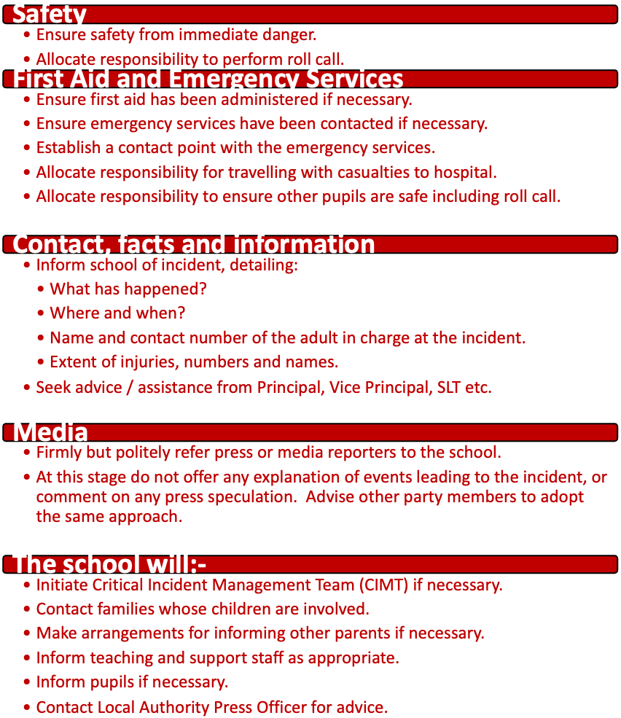

Key Contacts:

CONTACT ARRANGEMENTS FOR MANAGING CRITICAL INCIDENTS IN SCHOOLS AND CHILDREN’S CENTRES INVOLVING A CHILD, PUPIL OR MEMBER OF STAFF
Critical incidents involving a child, pupil or member of staff should be reported by the School/Children’s Centre/Service in the following way:- If a Critical Incident occurs OUT OF office hours -
before 8.30am, after 5.00pm & weekends/Bank Holidays
contact
Emergency Duty Team – EDT
0300 123 5022
If a Critical Incident occurs IN office hours -
8.30am-5.00pm Monday-Friday
contact
‘Children and Families Business Management Support Team’
on one of the following numbers:-
01606 275863 or 01606 271503

