
Cranberry Academy PSHE/ RSE Year One
Autumn Term 1

Topic: Making friends and playing and learning together
In this topic pupils will learn:
- What makes a good friend.
- How to be kind and caring to our friends.
- That friends sometimes fall out, but they can make up again.
- How to solve problems by talking and never by hurting someone.
- Who we can talk to if a friendship is making us feel sad or worried.
- How to ask before using or sharing things and how to say "yes" or "no" kindly.

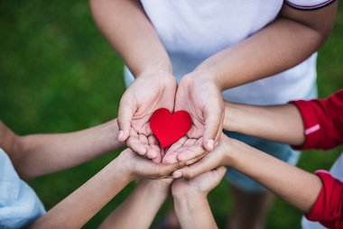

Cranberry Academy PSHE/ RSE Year One
Autumn term 2

Topic: Mental Health and wellbeing
In this topic we will learn:
- How to spot and name different feelings, like happy, excited, angry and sad.
- What distractions are and simple ways to help us focus.
- What helps us feel happy and healthy, like playing outside, sleeping well and spending time with people we love.
- How noticing our thoughts and feelings can help us look after ourselves.
- Who we can talk to when we are worried or need help with our feelings.

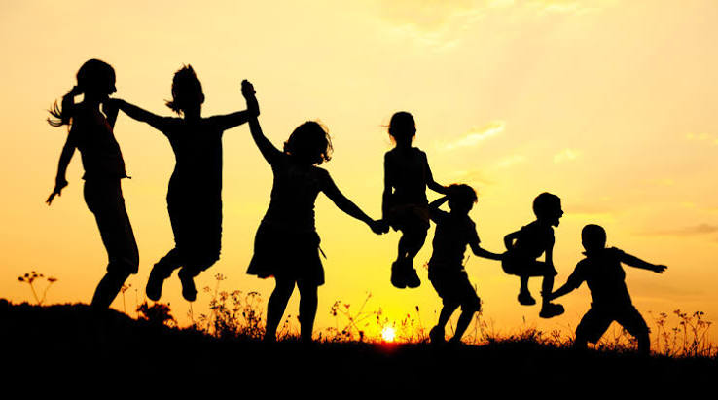

Cranberry Academy PSHE/ RSE Year One
Spring term 1

In this topic we will learn:
- What a family is and who is in our family.
- That every family is different and every family is special.
- What makes us unique and how we are the same as and different from others.
- The different groups we belong to and how they help us feel included.
- Different ways families show love and care for each other.
- Who we can talk to if something about our family is making us feel worried or upset.

Topic: Celebration: Me, you and
our families

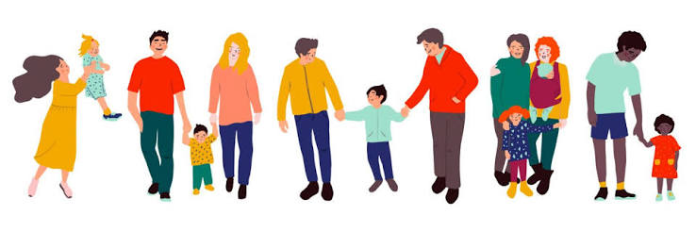

Cranberry Academy PSHE/ RSE Year One
Spring term 2

Topic: Safety at home

In this topic we will learn:
- Why we have rules and how they help to keep us safe.
- How to spot things at home that could be dangerous.
- That medicines can help us when they are used safely.
- That some things are not safe to eat, drink or touch.
- What to do and who to tell if we think something is unsafe.

Cranberry Academy PSHE/ RSE Year One
Summer term 1

Topic: Being healthy
In this topic we will learn:
- How to stay safe in the sun.
- Why sleep is important and how to have a good bedtime routine.
- How to brush our teeth properly and keep them healthy.
- How healthy food and drinks help our bodies grow strong.
- Who helps us stay healthy and who to ask if we feel poorly or get hurt.
- That people enjoy sharing food together.
- Where different foods come from and how some foods are made before we eat them.

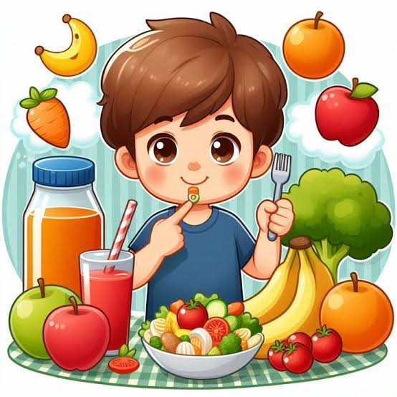

Cranberry Academy PSHE/ RSE Year One
Summer term 2


Topic: Showing kindness to ourselves and others
In this topic we will learn:
- That everyone has different likes, dislikes and needs.
- How to talk about our feelings and listen to other people.
- How to be polite, kind and respectful.
- How to play together, share and take turns.
- What to do if we feel upset or angry with someone.
- The difference between kind and unkind behaviour.
- What bullying is and why it is important to tell a trusted adult.
- Who we can ask for help if we are worried, upset or feel unsafe.

