
Cranberry Academy PSHE/ RSE Year Three
Autumn term 1
In this topic we will learn:
- That everyone is different and special in their own way.
- How our culture, family, beliefs, hobbies and interests make us who we are.
- Why it is important to respect and celebrate our differences.
- How kindness, trust and respect help us build good friendships.
- How to make and keep caring friendships.
- How to spot when a friendship is unkind or unsafe and who to ask for help.
- How to deal with disappointment or frustration in a calm and positive way.

Topic: Me, my friend and belonging


Cranberry Academy PSHE/ RSE Year Three
Autumn term 2

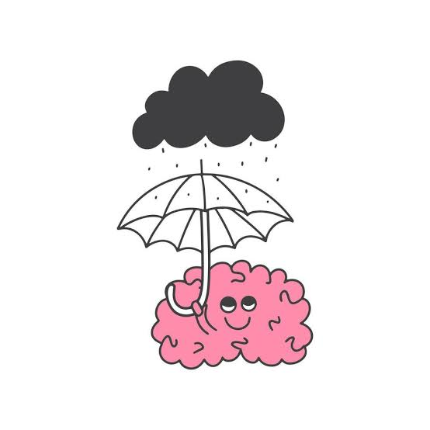
Topic: Mental health and wellbeing
In this topic we will learn:
- How to recognise and name a range of feelings.
- That everyone feels worried, lonely or sad sometimes.
- Why talking to someone we trust can help when we are upset.
- How to stay focused and manage distractions.
- Simple ways to calm our minds and manage our feelings.
- How looking after our feelings helps keep our minds healthy.

Cranberry Academy PSHE/ RSE Year Three
Spring term 1

Topic: Building healthy habitats
In this topic we will learn:
- What a healthy, balanced diet looks like.
- Which foods we should eat more often and which we should only have sometimes.
- Why eating a variety of foods helps us stay healthy.
- How food and drinks affect our bodies.
- How to make healthy food and drink choices.
- Why it is important to brush our teeth and visit the dentist.
- How keeping clean helps stop germs from spreading.




Cranberry Academy PSHE/ RSE Year Three
Spring term 2
In this topic we will learn:
- Why it is important to keep our information and location private online.
- How information shared online can be used in different ways.
- Why age limits and online rules help keep children safe.
- Why social media has age restrictions.
- How our choices online can affect our safety and wellbeing.
- Who to ask for help if something online worries us.
- How to balance screen time with other activities.
- How to be kind and respectful when communicating online.

Topic: Online choices


Cranberry Academy PSHE/ RSE Year Three
Summer term 1

Topic: Keeping safe out and about
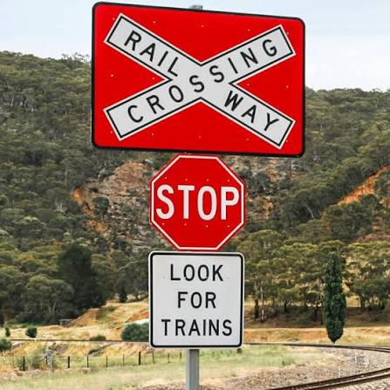
In this topic we will learn:
- How to stay safe in the sun and during hot weather.
- How to keep safe in places we know and places that are new to us.
- How to stay safe near roads, railways and water.
- How to spot risks and make safe choices.
- When and how to call the emergency services.
- Why staying safe is always more important than taking risks or filming an emergency.

Cranberry Academy PSHE/ RSE Year Three
Summer term 2

Topic: Looking out for each other
In this topic we will learn:
- About common dangers such as allergies, bites and stings.
- How to tell when someone might need help.
- When it is important to call the emergency services.
- How to stay calm and give clear information in an emergency.
- Why it is important to tell someone and get help when there is a problem.
- How to look after ourselves and help others safely.
- Who can help us when we are worried about our health, including doctors, nurses and trusted adults.



