
Cranberry Academy PSHE/ RSE Year Four
Autumn term 1

Topic: Mental health and wellbeing
In this topic we will learn:
- How to recognise, name and describe a wide range of feelings.
- Why looking after both our body and our mind is important.
- How positive thinking habits can help us in school and everyday life.
- How our feelings can affect our behaviour and the way we treat others.
- Different ways to manage worries and help ourselves feel calm.
- That change and loss are part of life and how people can cope with them.

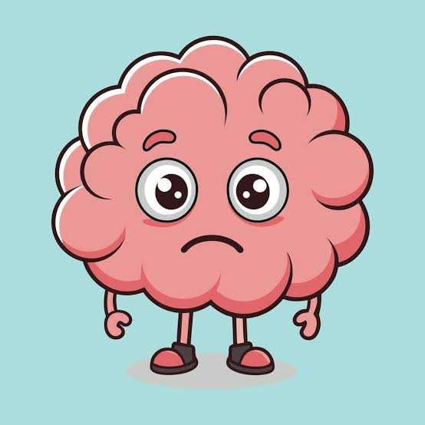

Cranberry Academy PSHE/ RSE Year Four
Autumn term 2

Topic: Exploring ways to manage risks
In this topic we will learn:
- How to stay safe in places we know and places that are new to us.
- How to stay safe near roads and traffic.
- How to enjoy fireworks safely by following important safety rules.
- How to stay safe when playing games online.
- How medicines can help us when they are used safely, and how to manage common health needs like allergies and asthma.
- How everyday substances, such as caffeine, alcohol, cigarettes, vapes and medicines, can affect our health.
- How to spot dangers at home, such as electrical appliances and fire risks, and how to stay safe.



Cranberry Academy PSHE/ RSE Year Four
Spring term 1

Topic: Forming respectful relationships
In this topic we will learn:
- Why good friendships are important for our happiness and wellbeing.
- What makes a healthy friendship and why friends should never be controlling or unkind.
- How to include others and enjoy different kinds of friendships.
- How to balance our own needs with the needs of our family and friends.
- How listening, kindness and respect help us build strong friendships.
- What bullying is, including online bullying, and what to do if we see or experience it.
- How to speak up confidently and respectfully while respecting other people.

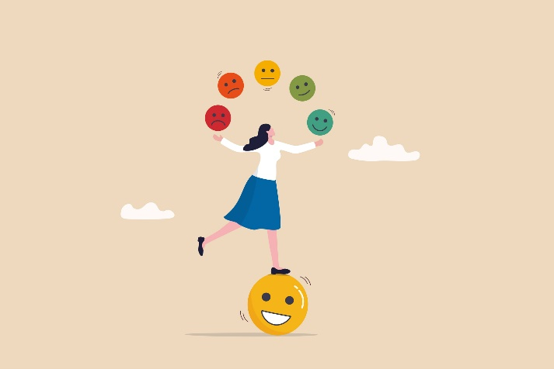

Cranberry Academy PSHE/ RSE Year Four
Spring term 2

Topic: Money matters and news literacy
In this topic we will learn:
- That people make different choices about spending and saving money.
- How needs and wants can affect the way people spend money.
- How our money choices can affect ourselves and other people.
- About different ways to pay for things and the advantages and disadvantages of each.
- How world events and news can affect our feelings.
- That not everything we see online or in the media is real or true.
- How to think carefully and ask questions about information we see.



Cranberry Academy PSHE/ RSE Year Four
Summer term 1

Topic: Safe connections online
In this topic we will learn:
- How to respond safely to adults we know and adults we do not know.
- Who we can talk to if we ever feel worried, uncomfortable or unsafe.
- That some relationships are unhealthy or unsafe.
- How to recognise warning signs and tell a trusted adult.
- Who our trusted adults are and where we can get help and advice.
- How to ask for help and keep asking until someone listens.
- How to use the internet safely, deal with peer pressure online and make positive choices

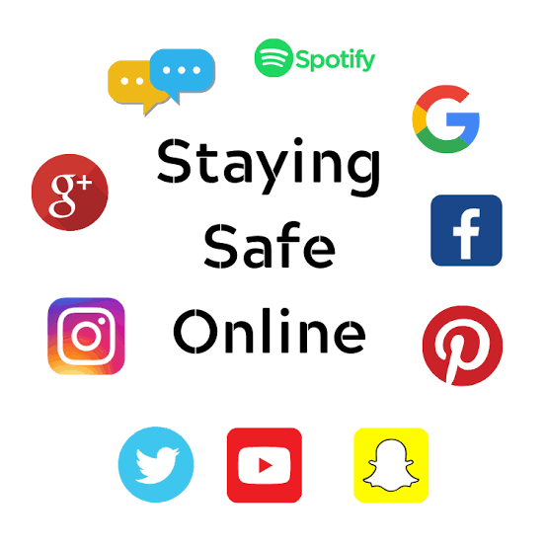

Cranberry Academy PSHE/ RSE Year Four
Summer term 2

Topic: Families and growing together
In this topic we will learn:
- About the different types of relationships people have.
- That every family is different and all families deserve respect.
- That families can change and help each other through difficult times.
- How families give love, care, protection and support.
- About changes that can happen in families, such as moving home or welcoming a new baby.
- That some adults choose to show their commitment through marriage or civil partnerships.

