
Cranberry Academy PSHE/ RSE Year Five
Autumn term 1

Topic: Friendships, Stereotypes and Bullying
In this topic we will learn:
- What makes a healthy friendship where everyone feels safe, happy and included.
- How to notice when someone feels lonely or left out and how to help them.
- Why trust, kindness, respect and loyalty are important in friendships.
- When being honest or loyal means asking a trusted adult for help.
- How bullying affects everyone and what to do if we see or experience it.
- What stereotypes are, why they are unfair and how to challenge them.
- How to solve disagreements calmly, fairly and without hurting others.

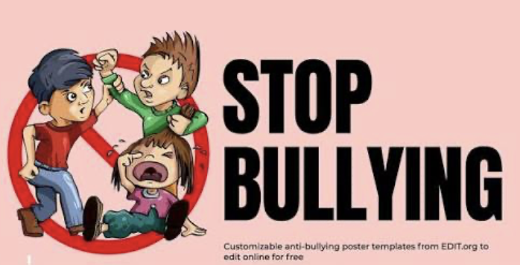

Cranberry Academy PSHE/ RSE Year Five
Autumn term 2

Topic: Mental Health and wellbeing
In this topic we will learn:
- That our feelings can change in strength and over time.
- How to stay focused and manage distractions.
- How practising calming strategies helps us use them more easily.
- That strong feelings lasting a long time may mean someone needs extra help.
- Who to talk to if we are worried about our own or someone else's mental health.
- Different ways to manage big emotions safely and positively.



Cranberry Academy PSHE/ RSE Year Five
Spring term 1

Topic: Making safe choices online and respecting others
In this topic we will learn:
- How to manage our feelings about things we cannot control.
- How to spot information online that is false or misleading.
- How online content is chosen and shown to different people.
- How to make safe and sensible choices when using the internet.
- Why we all have a responsibility to care for people, animals and the environment.
- How to show kindness, respect and care to others.
- How good manners and respect can look different in different cultures.

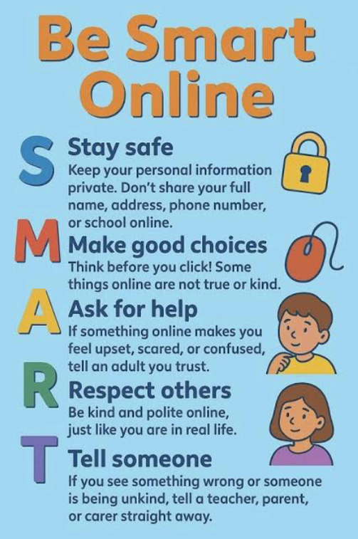

Cranberry Academy PSHE/ RSE Year Five
Spring term 2

Topic: Consent, boundaries and staying safe
In this topic we will learn:
- What consent means and how to ask for, give or refuse permission.
- The difference between appropriate and inappropriate physical contact.
- What to do if someone makes us feel uncomfortable or unsafe.
- How to deal with pressure from others to do something we do not want to do.
- The difference between safe secrets and secrets that should always be shared.
- When and how to tell a trusted adult if we are worried or feel unsafe.

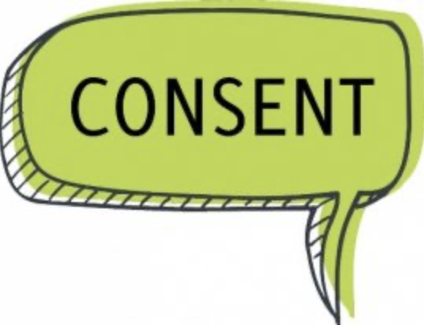

Cranberry Academy PSHE/ RSE Year Five
Summer term 1

Topic: Growing up and looking after our bodies
In this topic we will learn:
- About the physical and emotional changes that happen during puberty.
- How to prepare for changes such as periods and wet dreams.
- About the menstrual cycle and where to get help if needed.
- Why being active is important for a healthy body and mind.
- The difference between public and private, and why privacy matters.
- How to set and respect personal boundaries, including respecting everyone's body.

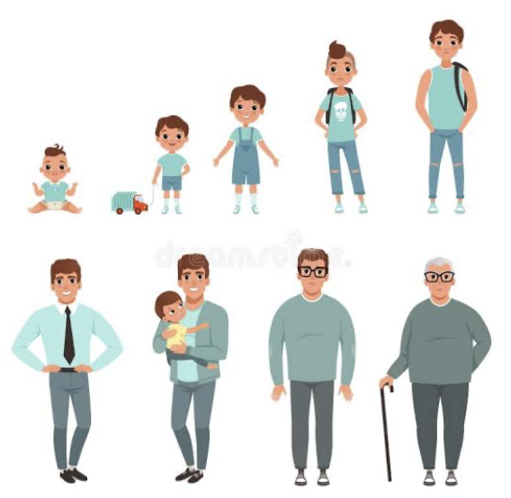

Cranberry Academy PSHE/ RSE Year Five
Summer term 2

Topic: Healthy lifestyles and first aid
In this topic we will learn:
- What it means to have a healthy and balanced lifestyle.
- How regular exercise helps keep our bodies and minds healthy.
- How to include active exercise in our everyday lives.
- How our choices can affect our health and wellbeing.
- Why spending too much time being inactive can be harmful.
- Who to ask for help if we are worried about our health and some basic first aid skills for common injuries.



