
Cranberry Academy PSHE/ RSE Year Six
Autumn term 1

Topic: Mental health and wellbeing
In this topic we will learn:
- How to manage our feelings, thoughts and reactions in different situations.
- How to recognise stress and use healthy ways to cope with challenges.
- How to stay focused and reduce distractions to help us learn and feel our best.
- Why healthy habits, such as getting enough sleep, being active and spending time outdoors, are good for our mental health.
- How practising calming and self-regulation strategies helps us build healthy habits over time.
- That everyone experiences change, loss and grief in different ways, and who we can turn to for help and support.

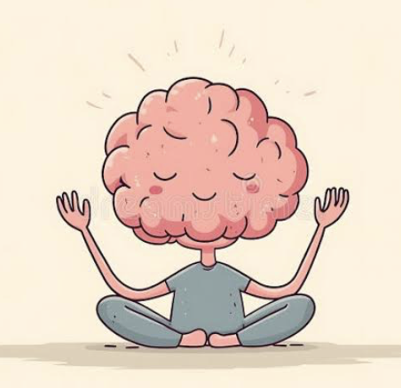

Cranberry Academy PSHE/ RSE Year Six
Autumn term 2
In this topic we will learn:
- How money can affect our feelings and who we can talk to if we are worried.
- The difference between things we need and things we want, and how this helps us make spending and saving choices.
- How the choices we make with money can affect other people and the environment.
- Why age restrictions and online rules help to keep us safe.
- How to stay safe when gaming online, including understanding the risks of spending money in games.
- How to spot online scams and fraud and what to do if something does not seem right.
- Different ways to keep money safe and keep track of it.

Topic: Managing money and online spending


Cranberry Academy PSHE/ RSE Year Six
Spring term 1
In this topic we will learn:
- About the physical and emotional changes that happen during puberty.
- The correct names for the main parts of the male and female reproductive systems.
- How babies are conceived and born as part of the human life cycle.
- That people may develop romantic feelings or crushes, and that these feelings can be towards people of the same or a different sex.
- How to recognise peer pressure and make positive, healthy choices.
- Why good-quality sleep is important for our health, learning and wellbeing.
- That female genital mutilation (FGM) is illegal, harmful and never acceptable, and how to get help if we are worried about someone.

Topic: Growing up, puberty and healthy relationships
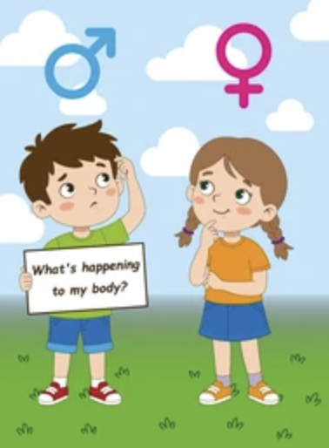

Cranberry Academy PSHE/ RSE Year Six
Spring term 2

Topic: Drug Education: assessing risk and managing influences
In this topic we will learn:
- How medicines can help us when they are used safely and correctly.
- That there are laws about legal and illegal drugs.
- How friends, family, the media and curiosity can influence people's choices about alcohol, nicotine and other drugs.
- Why alcohol, tobacco, vapes and other drugs can harm our health and become addictive.
- How advertising and the media can influence the way people think about alcohol, vaping and smoking.
- Who can help people who are worried about alcohol, nicotine or other drugs, and who we can talk to if we are concerned.



Cranberry Academy PSHE/ RSE Year Six
Summer term 1

Topic: Developing our AI literacy
In this topic we will learn:
- How to protect our personal information and respect other people's privacy online.
- What artificial intelligence (AI) is and where we might use it in everyday life.
- How talking to an AI is different from talking to a real person.
- The similarities and differences between communicating online and face to face.
- How to stay safe when meeting people online and what to do if something worries us.
- Why we should think carefully before sharing words, photos or videos online because they can be difficult to remove.

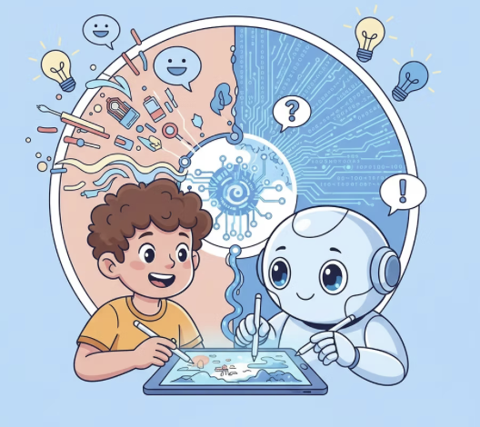

Cranberry Academy PSHE/ RSE Year Six
Summer term 2
In this topic we will learn:
- Who to ask for help if we are worried about our own or someone else's mental health or wellbeing.
- How skills like teamwork, communication, problem-solving and using technology can help us in the future.
- About the wide variety of jobs and careers people can choose.
- How our interests, strengths and goals can help shape our future careers, and why everyone should have equal opportunities.
- That people earn different salaries, and that money is only one part of choosing a career.
- About different routes into jobs, including college, apprenticeships and university, and how jobs may change in the future.
- Why stereotypes should never limit anyone's career choices.

Topic: Looking ahead: Wellbeing, careers and the future.


