KS2 French
Progression Map
KS2 National Curriculum Expectations
Pupils should be taught to:
- listen attentively to spoken language and show understanding by joining in and responding
- explore the patterns and sounds of language through songs and rhymes and link the spelling, sound and meaning of words
- engage in conversations; ask and answer questions; express opinions and respond to those of others; seek clarification and help
- speak in sentences, using familiar vocabulary, phrases and basic language structures
- develop accurate pronunciation and intonation so that others understand when they are reading aloud or using familiar words and phrases
- present ideas and information orally to a range of audiences
- read carefully and show understanding of words, phrases and simple writing
- appreciate stories, songs, poems and rhymes in the language
- broaden their vocabulary and develop their ability to understand new words that are introduced into familiar written material, including through using a dictionary
- write phrases from memory, and adapt these to create new sentences, to express ideas clearly
- describe people, places, things and actions orally* and in writing Languages –
- understand basic grammar appropriate to the language being studied, including (where relevant): feminine, masculine and neuter forms and the conjugation of high-frequency verbs; key features and patterns of the language; how to apply these, for instance, to build sentences; and how these differ from or are similar to English.

Intent

At Cranberry, our curriculum enables learners to manipulate language so that they can build their own meaning, sentences and structures independently. It develops pupils to be effective communicators who can confidently use their knowledge and skills to become global citizens and lifelong linguists, with a clear understanding of language and culture.

Implementation
In ensuring high standards of teaching and learning in French, we implement a curriculum that is progressive throughout Key stage two. Each year group is now following its own programme of study, which builds on learning from the previous year and contributes to secure development of the National Curriculum objectives. The children are taught a series of lessons by the class teacher which is taken from the Oak Academy programme of learning where children are given opportunities to practise all four skills of language learning through a range of practical and written activities.

Impact

The impact and measure of this is to ensure that children at Cranberry are equipped with French skills and knowledge that will enable them to be ready for the French curriculum at Key Stage 3 and for life as an adult in the wider world. We want French to be memorable and enjoyable, therefore encouraging children to undertake new life experiences now and in the future. Much of the work is completed through oral conversations and then assessed against the objectives and after completing an end of unit assessment.

Progression Map

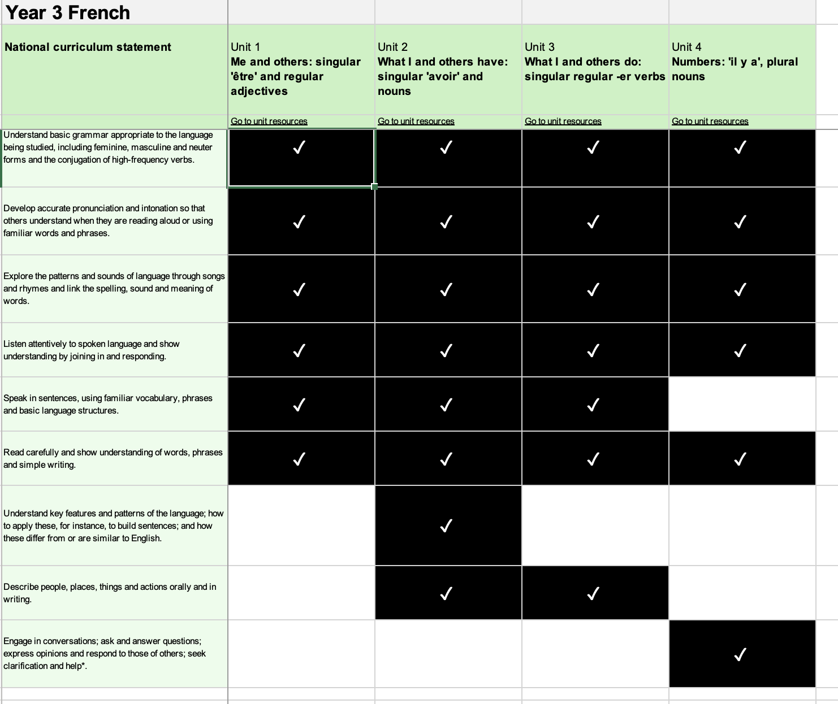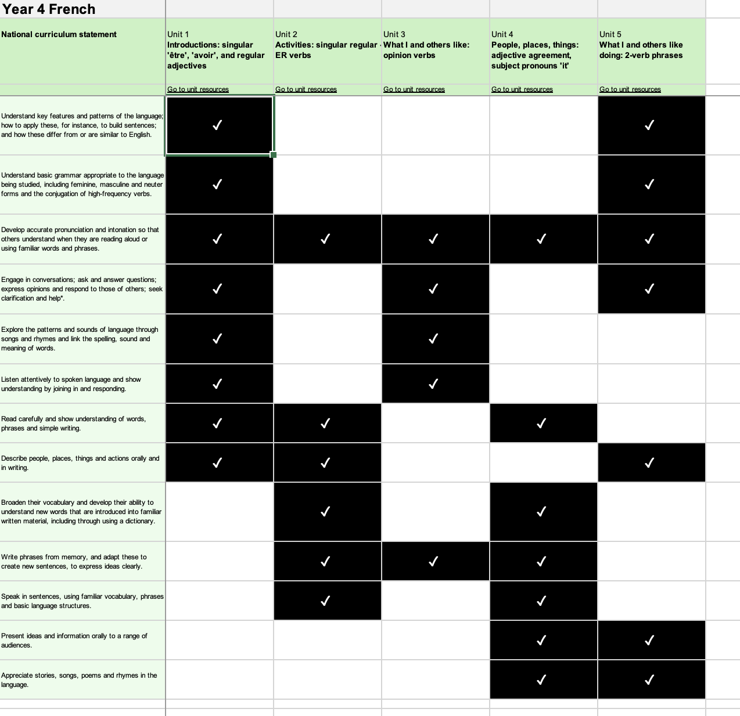
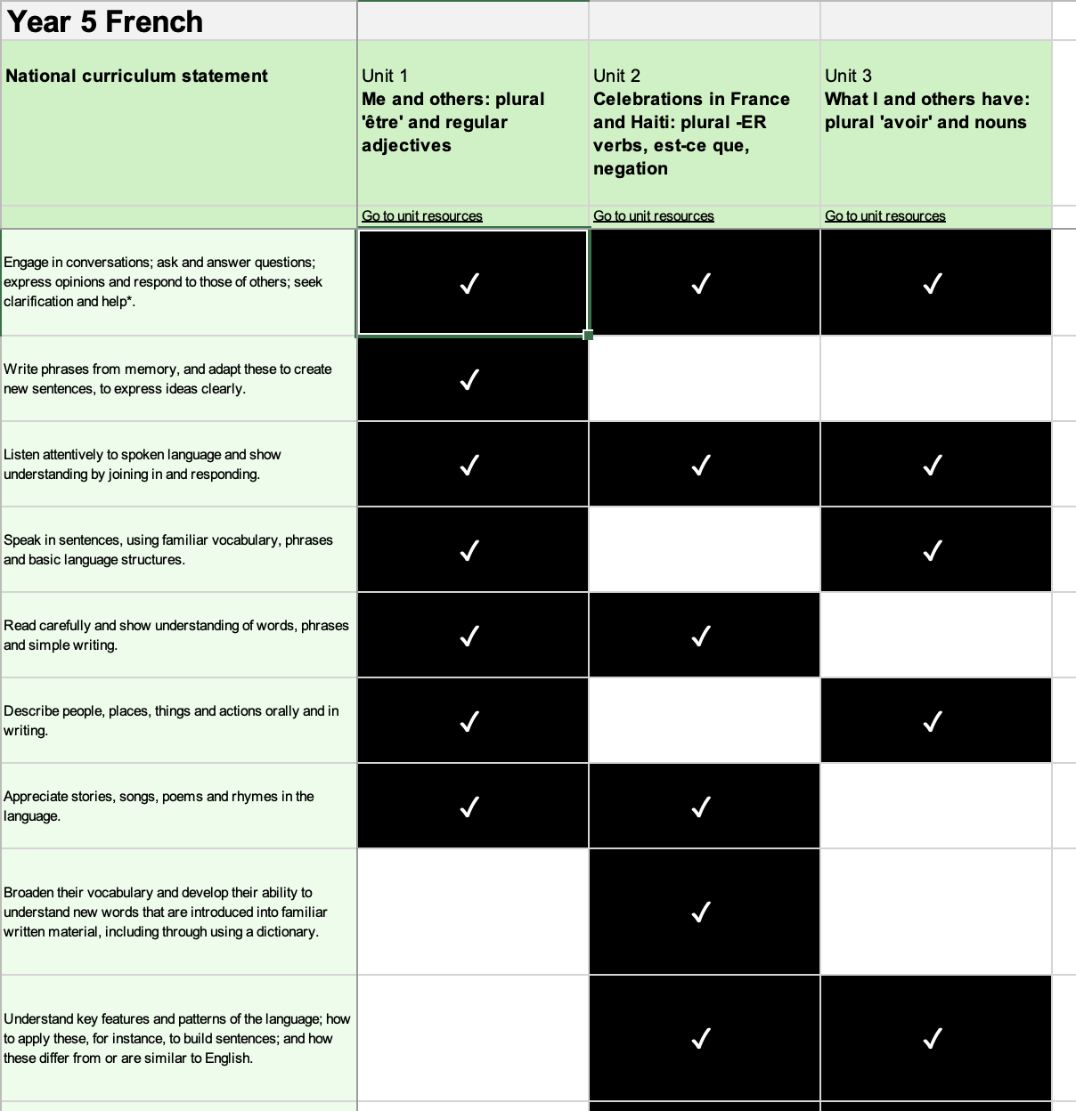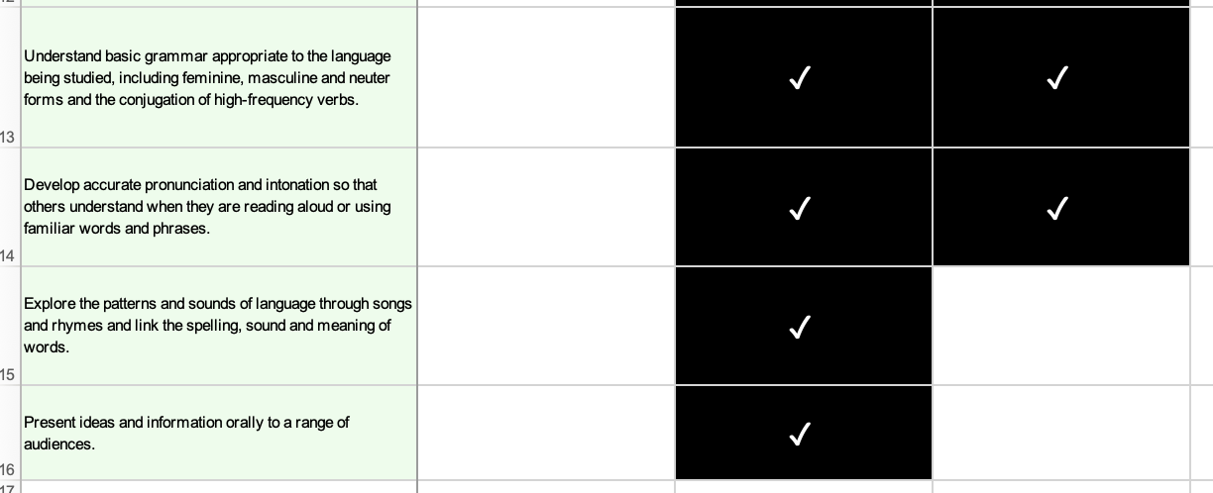

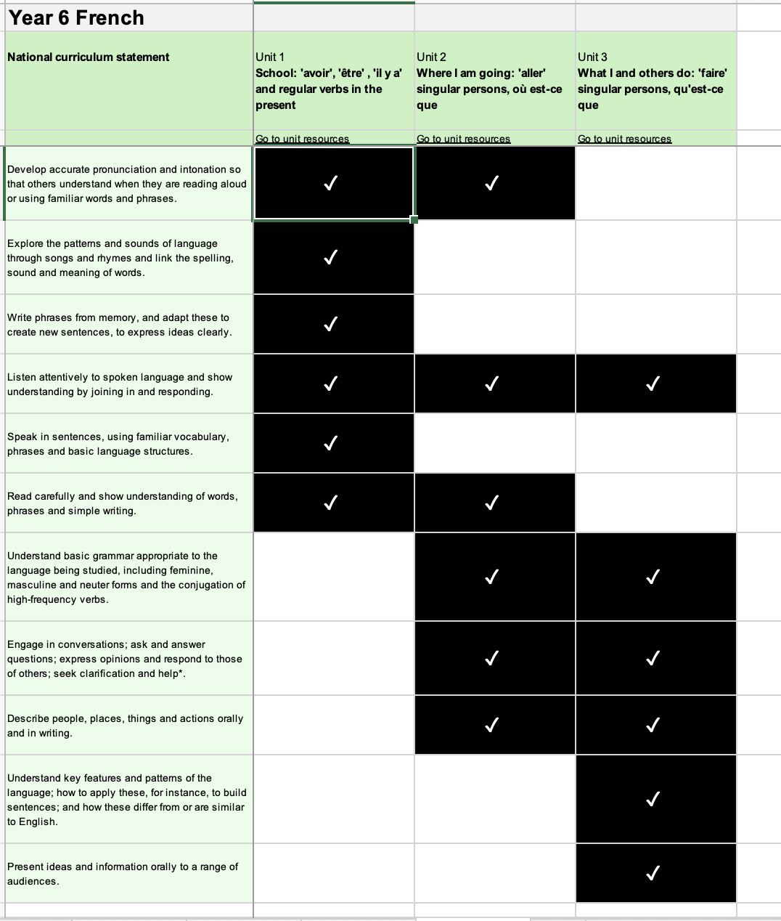
Our Long Term Overview KS2

