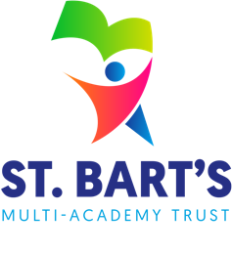
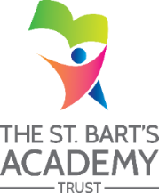
ST. BART’S MULTI-ACADEMY TRUST
Safeguarding Statement of Intent



St. Bart’s Mission
We ensure that every academy is a flourishing community, dedicated to releasing potential and inspiring ambitious futures through exceptional education.

St. Bart’s Vision and Values
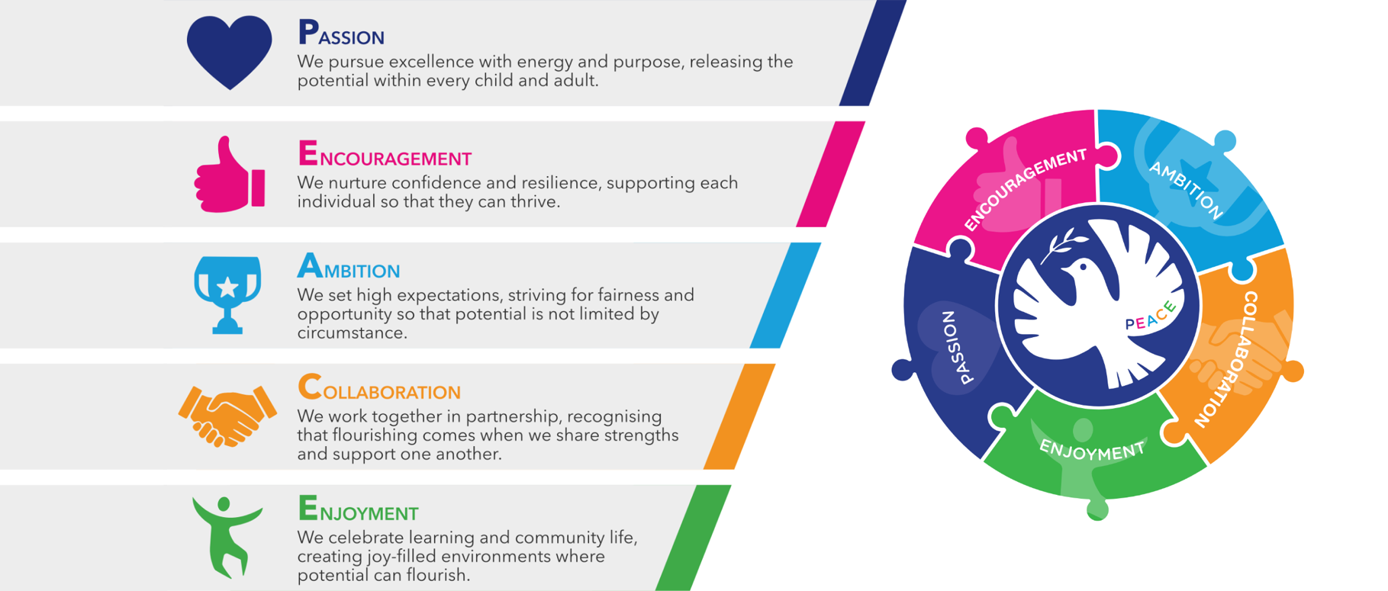
Releasing potential together through PEACE:

Our Trust Christian ethos is captured by the PEACE values and all schools work in close partnership (whether C of E or community) to ensure that all children, adults and the communities they serve flourish just as Jesus encouraged us to do in John 10:10 – “I have come that they may have life, and have it to the full.”
St. Bart’s vision includes a strong commitment to preparing our children for a world impacted by climate change, through learning and practical experience. We encourage pupils and staff to consider the impact of their actions locally and globally, while embedding climate change education across our curriculum, and sustainability into our ethos and Trust-wide practice.

Academy Safeguarding Expectations
Everyone working across St Bart’s Multi-Academy Trust is wholly committed to promoting the welfare of children. All children have a right to be protected from abuse regardless of their age, gender, disability, culture, language, racial origin, religious belief or sexual identity.
To fulfil this commitment, comprehensive safeguarding and child protection systems are in place in line with the DfE statutory guidance, Keeping Children Safe in Education (KCSIE) 2026.
The Trust believes that safeguarding and promoting the welfare of children is the responsibility of everyone. This is demonstrated through our shared culture of safeguarding. Everyone who comes into contact with children and their families has a role to play and all staff make sure their approach is wholly child centred. This means that at all times, they consider what is in the best interests of the child.
We will seek to keep children and young people safe by:
- Valuing, listening to and respecting them - embedding a culture where the voice of the child is paramount. ∙ providing help and support to meet the needs of children as soon as problems emerge. ∙ protecting children from maltreatment, whether that is within or outside the home, including online. ∙ preventing the impairment of children’s mental and physical health or development. ∙ ensuring that children grow up in circumstances consistent with the provision of safe and effective care.
- Taking action to enable all children to have the best outcomes.
- Appointing a nominated Designated Safeguarding Lead (DSL) and at least one Deputy Designated Safeguarding Lead in each academy who share overall accountability for safeguarding in their academy and whose names are clearly displayed for staff, pupils, and visitors to refer to. In accordance with KSCIE (2026), training for DSLs is formally refreshed every two years, and updated at least annually with ‘in house’ training.
- Appointing a named link governor for Safeguarding. The link governor will review the academy safeguarding arrangements on at least a termly basis.
- Adopting child protection and safeguarding best practice through our policies, procedures and Code of Conduct for staff and volunteers for appropriate action to be taken in a timely manner to safeguard and promote children’s welfare.
- Reviewing and scrutinising academy systems and procedures through regular monitoring by the both the link governor for Safeguarding and the Trust Safeguarding Lead. Academies are expected to complete the relevant LA Section 175 audit and Trust ‘in house’ good practice audits in partnership with their safeguarding lead governor.
- Recruiting and selecting staff and volunteers safely, ensuring all academies adhere to safer recruitment practices. Those involved with the recruitment and employment of staff to work with children will have received appropriate safer recruitment training.
- Recording, storing and using information professionally and securely, in line with data protection legislation and guidance.
- Providing effective management for staff and volunteers through supervision, support, training and quality assurance measures so that all staff and volunteers know about and follow our systems and policies, procedures and behaviour codes confidently and competently and that they have an awareness of safeguarding issues that can put children at risk of harm. This includes reading Part One of KSCIE 2026, the Child Protection policy, the Staff Code of Conduct, the Behaviour policy and the academy’s procedures for children who are absent from education
- Using the published procedures to manage any allegations against staff and volunteers appropriately. ∙ creating and maintaining an anti-bullying environment and ensuring that we have a policy and procedure to help us deal effectively with any bullying that does arise.
- Ensuring that we have effective complaints and whistleblowing measures in place and that these have been communicated across every academy community.
- Building a safeguarding culture where staff and volunteers, children, young people and their families, treat each other with respect and are comfortable about sharing concerns.
- Sharing information about safeguarding and good practice with children and their families via leaflets, posters, group work and one-to-one discussions.
- Making sure that children, young people and their families know where to go for help if they have a concern.

- Ensuring that we provide a safe physical environment for our children, young people, staff and volunteers, by applying health and safety measures in accordance with the law and regulatory guidance.

Trust Board Responsibilities

The St Bart’s Board of Trustees understands its statutory duties as outlined in the Safeguarding and Welfare Requirements in the Statutory Framework for the Early Years Foundation Stage (EYFS) 2026, Working Together to Safeguard Children 2023 (updated March 2026), the Prevent Duty for Schools (updated 2023) and Keeping Children Safe in Education 2026.
The Board of Trustees for St Bart’s Multi-Academy Trust has ultimate responsibility for Safeguarding issues. The Trust has appointed a Trust Safeguarding Lead, Kim Webb, who is available at all times to support the Academy teams with Child Protection and Safeguarding policies and procedures.
Designated Safeguarding Leads
Operationally, the responsibility for safeguarding is delegated to the Principals and Designated Safeguarding Leads who ensure the day-to-day care and safety of pupils and manage child protection issues within their relevant Academy. Currently, every Academy has a Designated Safeguarding Lead and a Deputy Designated Safeguarding Lead who share lead responsibility with Principals for safeguarding and child protection within their own Academy. They are clear about their role, have sufficient time and receive relevant support, and training, to undertake their responsibilities, which includes close contact with outside agencies including social services, the Local Safeguarding Children’s Board and relevant health care organisations.

Academy Safeguarding Expectations
∙ providing effective management for staff and volunteers through supervision, support, training and quality assurance measures so that all staff and volunteers know about and follow our systems and policies, procedures and behaviour codes confidently and competently and that they have an awareness of safeguarding issues that can put children at risk of harm. This includes reading Part One of KSCIE 2026, (and Annex A where relevant), the Child Protection policy, the Staff Code of Conduct, the Behaviour policy and the academy’s procedures for children who are absent from education
Safeguarding and Child Protection policies and procedures
The Trust ensures all Academy policies and procedures in respect of safeguarding children are up to date and in line with Keeping Children Safe in Education 2026. Policies and procedures are reviewed and revised by Academy Principals, Designated Safeguarding Leads and Local Governing Committees on a regular basis (at least annually). The MAT has implemented a Safeguarding and Child protection policy to ensure compliance to statutory guidance. Our academies are directed to contextualise the policy to reflect their academy needs.
Policies are accessible to all staff and parents through the individual Academy websites. This includes, for example, the name of the Designated Safeguarding Leads and their deputies and how to raise a safeguarding concern. Academies use CPOMS to record concerns, information and actions towards keeping pupils safe.
Disclosure and Barring Service (DBS) and Employment Checks
St Bart’s Multi-Academy Trust meets statutory requirements in relation to Disclosure & Barring Service as outlined in Keeping Children Safe in Education 2026. All staff, members, Trustees, Governors and volunteers who meet the ‘regulated activity test’ are required to undergo an enhanced DBS, a range of recruitment and safeguarding checks and online checks prior to employment or engagement. Each Academy’s Single Central Record (SCR) details safer recruitment checks and DBS information. These are regularly monitored in person by the Chair of Governors, the academy’s DSL, SLT and the MAT Central Leadership team. It is also remotely monitored through the MAT SCR Teams Channel.

Safer Recruitment Practices
The Trust is committed to creating a culture of safe recruitment and, as part of this, adopts consistent recruitment procedures across all its Academies that help deter, reject or identify people who might present a risk to children. The Trust and its Academies act reasonably in making decisions about the suitability of any prospective member of staff, governors and volunteers based on relevant checks and evidence, including criminal record checks, enhanced DBS checks, barred list checks, Section 128 checks, prohibition checks, medical suitability and childcare disqualification checks, together with references information, online checks and interview information where appropriate, according to role. The academy will also make online social media checks.
Contractors are expected to adhere to our stringent safer recruitment checks and provide our MAT with letters of assurance that detail safer recruitment checks and spot checks are performed by our MAT to ensure that our children and adults are safe.
Where an Academy places a pupil with an alternative provision provider, the Academy continues to be responsible for the safeguarding of that pupil. Our Academies obtain written confirmation from the alternative provision provider that appropriate safeguarding checks have been carried out on individuals working at the establishment.

This includes written confirmation that the alternative provider will inform the commissioning school of any arrangements that may put the child at risk (i.e. staff changes), so that the commissioning school can ensure itself that appropriate safeguarding checks have been carried out on new staff.
Professional Development and Training
All eligible staff, governors, trustees and volunteers are required to undertake relevant safeguarding training (core
and specific) and this is regularly reviewed by each Academy’s Designated Safeguarding Lead to ensure it is up to date. Training plans ensure everyone has the knowledge and skills required to carry out their role and responsibilities safely and with confidence. They also reflect the academy’s training needs in relation to context and extra familial harm. Across the Trust and its academies, all staff are consistently reminded of the systems, policies and procedures used to support child protection and safeguarding. These are also explained as part of staff induction and reviewed with all staff at the start of every academic year and throughout the year as policy changes happen.
There is a Trust DSL Network, facilitated by the Trust Safeguarding Lead and made up of one DSL representative from each Academy, which meets regularly (at least termly) to talk through new initiatives, training opportunities, local issues and the wider perspectives involving child protection. DSLs also receive regular supervision sessions with an external provider.
Attendance
Academies are aware that children being absent from school, particularly repeatedly and/or for prolonged periods, and children missing education can act as a vital warning sign of a range of safeguarding possibilities. This may include abuse and neglect such as sexual abuse or exploitation and can also be a sign of child criminal exploitation including involvement in county lines. It may indicate mental health problems, risk of substance abuse, risk of travelling to conflict zones, risk of female genital mutilation, so called ‘honour’-based abuse or risk of forced marriage.
We recognise that early intervention is essential to identify the existence of any underlying safeguarding risk and to help prevent the risks of a child going missing in future. Therefore, all staff will receive training on attendance, with dedicated attendance training for any staff with a specified attendance function in their role, including administrative, pastoral or family support staff, and senior leaders.
Curriculum
Every Academy makes age-appropriate provision and curriculum for teaching children about how to keep themselves safe, including online, and enjoy healthy lifestyles, as part of each Academy’s personalised approach to delivery of the PSHE, RSHE and Computing and online curriculums. The four Cs of online risk (content, contact, conduct and commerce) are integrated in academy computing and online safety throughout the MAT. Artificial Intelligence is integrated into the academy’s safeguarding curriculum to raise safety awareness for our pupils. These curriculum documents also reflect the contextual and extra familial harm needs of the Academy’s catchment needs to ensure that the children know how to keep themselves safe.

Monitoring
Safeguarding and Child Protection is reviewed annually in each Academy by the Trust Safeguarding Lead; audits and reviews are undertaken to ensure that safeguarding systems and processes are working.
These include:
- Monitoring of each Academy’s Single Central Record
- Monitoring of Safeguarding Policies and Procedures including, an audit of CPOMS records and the effectiveness of report writing
- Website compliance checks in relation to safeguarding expectations
- Safeguarding learning walks
- A medicines compliance check
- An Filtering and monitoring check
- An analysis of persistent absence in relation to safeguarding expectations
- A pupil voice opportunity to discuss safeguarding, child on child abuse, behaviour and bullying
- A safeguarding discussion with SLT
- An audit of completed training for all employees and volunteers, guidance and support
A full written summary of the findings and actions that need attention is produced which is shared with the Trust Central Leadership Team, the Academy’s SLT and each Local Governing Committee.

Any areas of need are followed up with each Academy with actions revisited to ensure compliance.
The Trust Safeguarding Lead has implemented a safeguarding monitoring timetable for each Academy to make sure that key safeguarding practices are in place. This strategy confirms consistency, communication and continuous development.
Each Academy has a named linked governor for safeguarding. The nominated governor reviews safeguarding procedures across their Academy at least termly and reports back to the Local Governing Committee.
The Single Central Record is audited, on at least three occasions during an academic year by either a member of the Trust SLT, the Trust Safeguarding Lead or the nominated Safeguarding Governor / Chair of Governors. Principals maintain responsibility for ensuring that all appropriate checks are completed and that the Single Central Record is accurate and up to date.

The Trust Safeguarding Lead and School Improvement Officers are responsible for supporting Principals to fulfil their statutory duties and hold them to account.
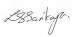
Lisa Sarikaya
Chief Executive Officer
SBMAT Board of Trustees Chief Executive Officer
Revised September 2026

